**Online Food Ordering**

**Admin table :**

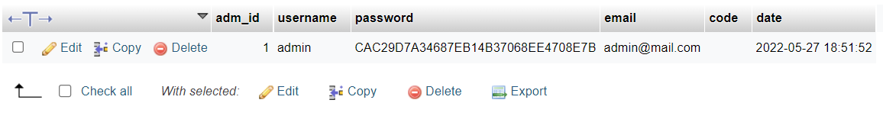

**Dishes table :**

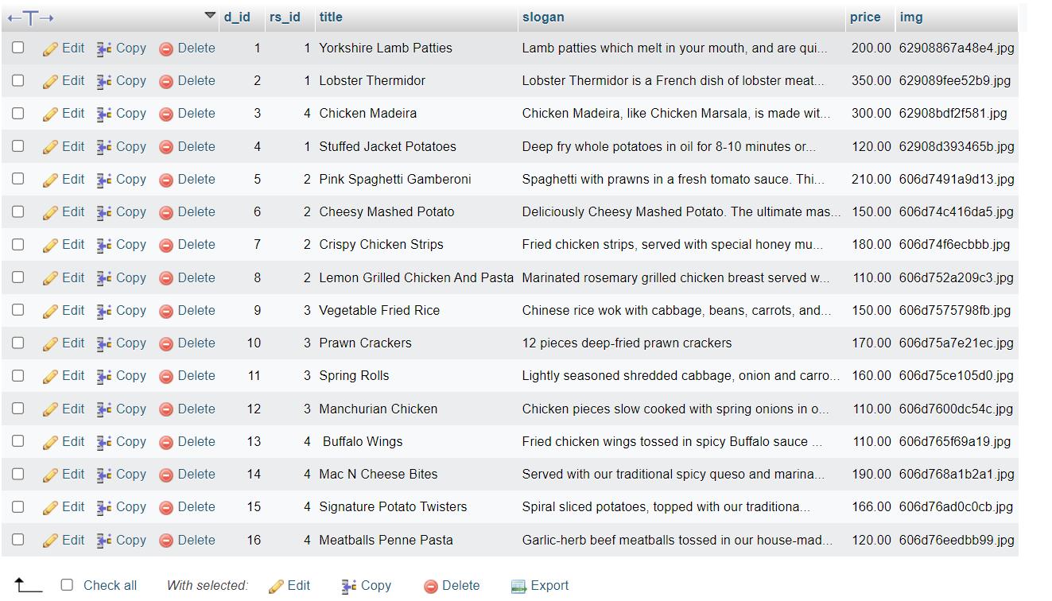

**Remark table:**

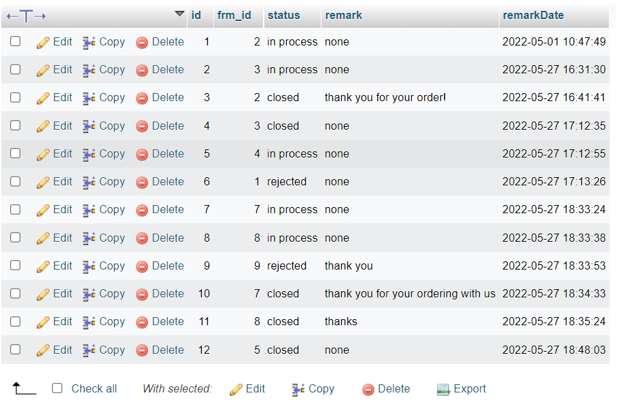

**Restaurant table:**

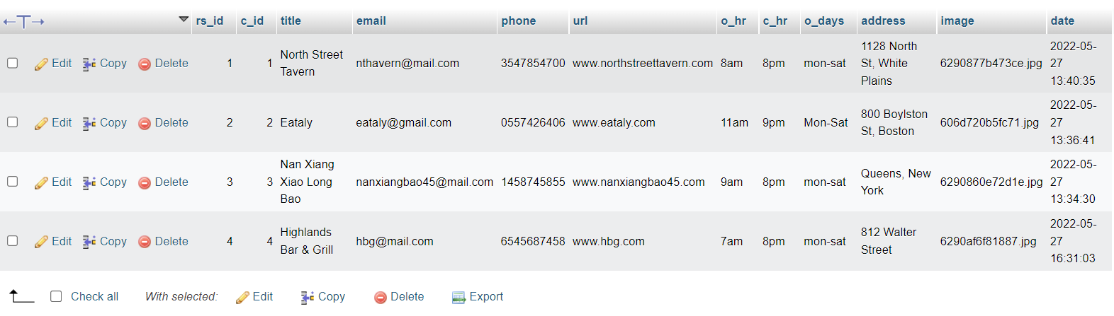

**Res_category table:**

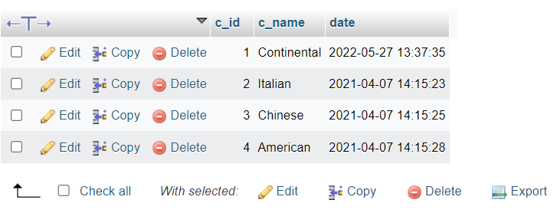

**User table:**

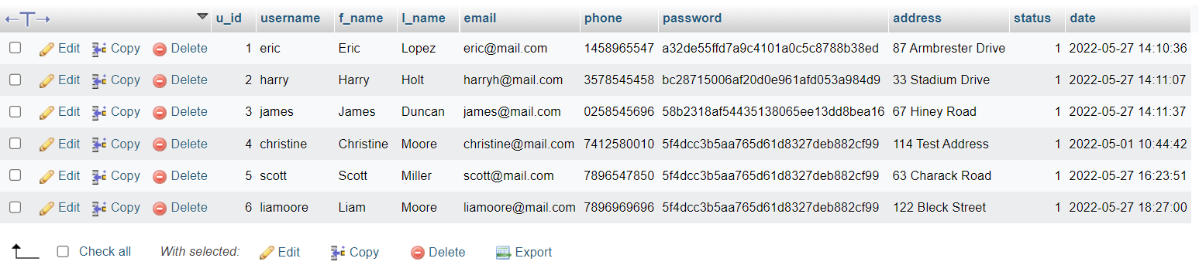

**User_orders table :**

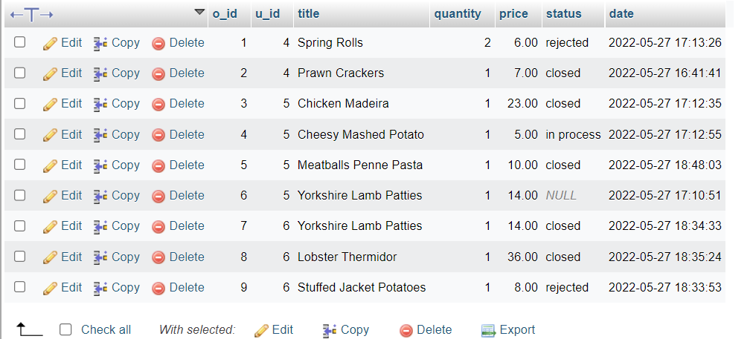

**Front_End**

**Index.php file:**

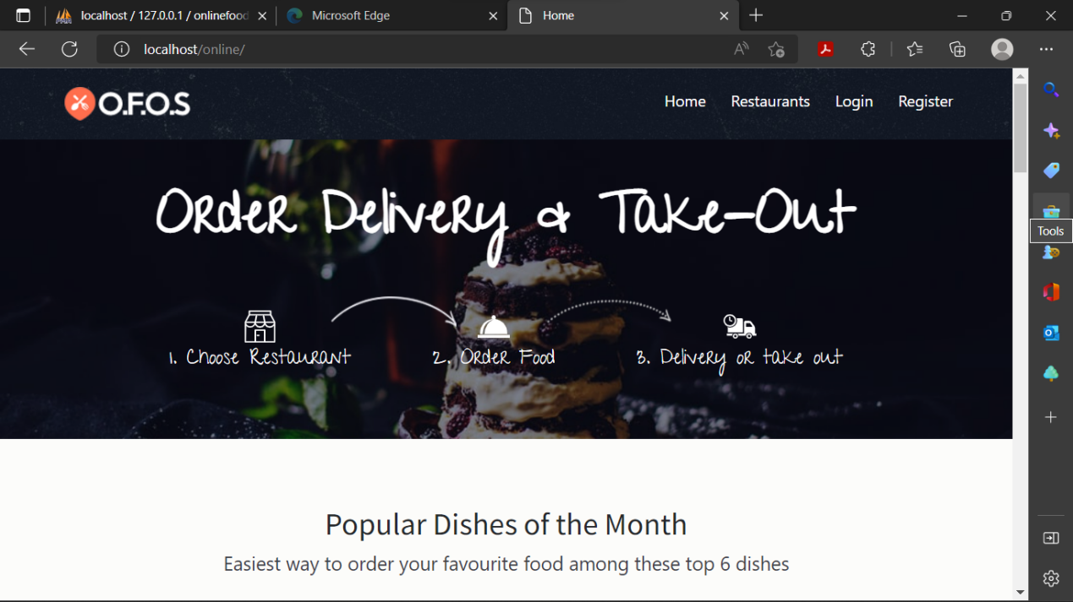

**Login.php:**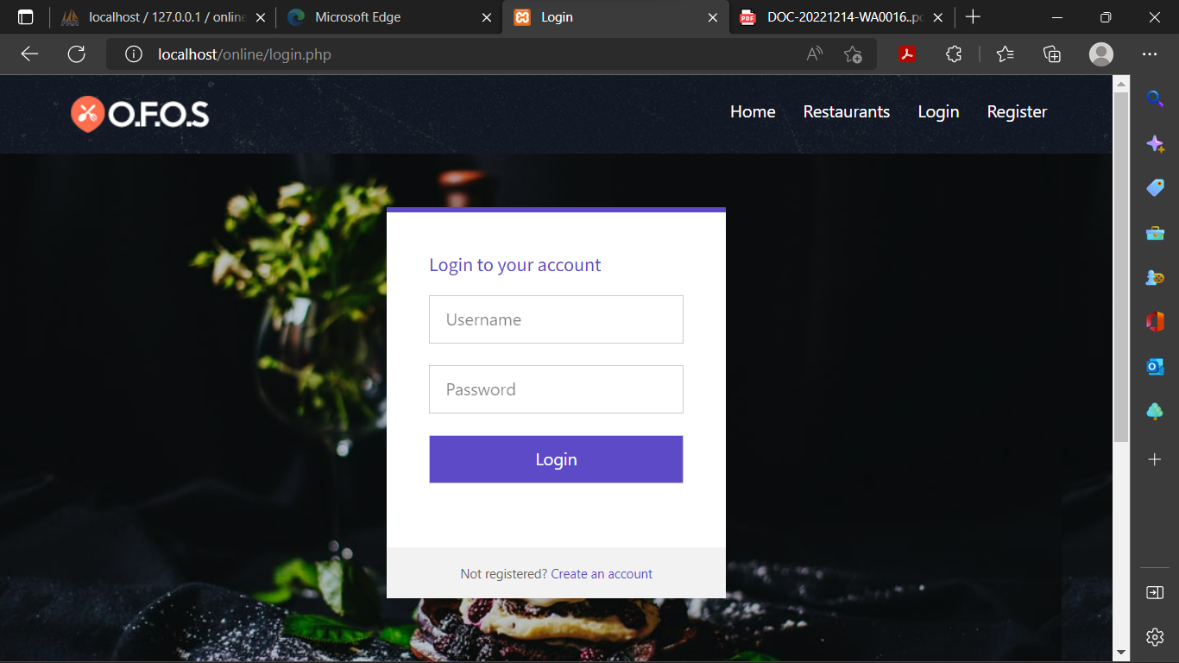

**<!DOCTYPE html>**

**<html lang="en" >**

**<head>**

**<meta charset="UTF-8">**

**<title>Login</title>**

**<link rel="stylesheet" href="https://cdnjs.cloudflare.com/ajax/libs/meyer-reset/2.0/reset.min.css">**

**<link rel='stylesheet prefetch' href='https://fonts.googleapis.com/css?family=Roboto:400,100,300,500,700,900|RobotoDraft:400,100,300,500,700,900'>**

**<link rel='stylesheet prefetch' href='https://maxcdn.bootstrapcdn.com/font-awesome/4.3.0/css/font-awesome.min.css'>**

**<link rel="stylesheet" href="css/login.css">**

**<style type="text/css">**

**#buttn{**

**color:#fff;**

**background-color: #5c4ac7;**

**}**

**</style>**

**<meta name="viewport" content="width=device-width, initial-scale=1, shrink-to-fit=no">**

**<link href="css/bootstrap.min.css" rel="stylesheet">**

**<link href="css/font-awesome.min.css" rel="stylesheet">**

**<link href="css/animsition.min.css" rel="stylesheet">**

**<link href="css/animate.css" rel="stylesheet">**

**<link href="css/style.css" rel="stylesheet">**

**</head>**

**<body>**

**<header id="header" class="header-scroll top-header headrom">**

**<nav class="navbar navbar-dark">**

**<div class="container">**

**<button class="navbar-toggler hidden-lg-up" type="button" data-toggle="collapse" data-target="#mainNavbarCollapse">&#9776;</button>**

**<a class="navbar-brand" href="index.php"> <img class="img-rounded" src="images/icn.png" alt=""> </a>**

**<div class="collapse navbar-toggleable-md float-lg-right" id="mainNavbarCollapse">**

**<ul class="nav navbar-nav">**

**<li class="nav-item"> <a class="nav-link active" href="index.php">Home <span class="sr-only">(current)</span></a> </li>**

**<li class="nav-item"> <a class="nav-link active" href="restaurants.php">Restaurants <span class="sr-only"></span></a> </li>**

**<?php**

**if(empty($_SESSION["user_id"]))**

**{**

**echo '<li class="nav-item"><a href="login.php" class="nav-link active">Login</a> </li>**

**<li class="nav-item"><a href="registration.php" class="nav-link active">Register</a> </li>';**

**}**

**else{**

**echo '<li class="nav-item"><a href="your_orders.php" class="nav-link active">My Orders</a> </li>';**

**echo '<li class="nav-item"><a href="logout.php" class="nav-link active">Logout</a> </li>';**

**}?>**

**</ul>**

**</div>**

**</div>**

**</nav>**

**</header>**

**<div style=" background-image: url('images/img/pimg.jpg');">**

**<?php**

**include("connection/connect.php");**

**error_reporting(0);**

**session_start();**

**if(isset($_POST['submit']))**

**{**

**$username = $_POST['username'];**

**$password = $_POST['password'];**

**if(!empty($_POST["submit"]))**

**{**

**$loginquery ="SELECT * FROM users WHERE username='$username' && password='".md5($password)."'"; //selecting matching records**

**$result=mysqli_query($db, $loginquery); //executing**

**$row=mysqli_fetch_array($result);**

**if(is_array($row))**

**{**

**$_SESSION["user_id"] = $row['u_id'];**

**header("refresh:1;url=index.php");**

**}**

**else {**

**$message = "Invalid Username or Password!";**

**} }}?>**

**<div class="pen-title">**

**</div>**

**<div class="module form-module">**

**<div class="toggle">**

**</div>**

**<div class="form">**

**<h2>Login to your account</h2>**

**<span style="color:red;"><?php echo $message; ?></span>**

**<span style="color:green;"><?php echo $success; ?></span>**

**<form action="" method="post">**

**<input type="text" placeholder="Username" name="username"/>**

**<input type="password" placeholder="Password" name="password"/>**

**<input type="submit" id="buttn" name="submit" value="Login" />**

**</form>**

**</div>**

**<div class="cta">Not registered?<a href="registration.php" style="color:#5c4ac7;"> Create an account</a></div>**

**</div>**

**<script src='http://cdnjs.cloudflare.com/ajax/libs/jquery/2.1.3/jquery.min.js'></script>**

**<div class="container-fluid pt-3">**

**<p></p>**

**</div>**

**<footer class="footer">**

**<div class="container">**

**<div class="bottom-footer">**

**<div class="row">**

**<div class="col-xs-12 col-sm-3 payment-options color-gray">**

**<h5>Payment Options</h5>**

**<ul>**

**<li>**

**<a href="#"> <img src="images/paypal.png" alt="Paypal"> </a>**

**</li>**

**<li>**

**<a href="#"> <img src="images/mastercard.png" alt="Mastercard"> </a>**

**</li>**

**<li>**

**<a href="#"> <img src="images/maestro.png" alt="Maestro"> </a>**

**</li>**

**<li>**

**<a href="#"> <img src="images/stripe.png" alt="Stripe"> </a>**

**</li>**

**<li>**

**<a href="#"> <img src="images/bitcoin.png" alt="Bitcoin"> </a>**

**</li>**

**</ul>**

**</div>**

**<div class="col-xs-12 col-sm-4 address color-gray">**

**<h5>NAME</h5>**

**<p>Edrich Ryan Cardozo </p>**

**<h5>Roll number: 20CE21</a></h5> </div>**

**<div class="col-xs-12 col-sm-5 additional-info color-gray">**

**<h5>Addition informations</h5>**

**<p>Online Food Ordering DBMS project by 20CE21.</p>**

**</div>**

**</div>**

**</div>**

**</div>**

**</footer>**

**</body>**

**</html>**

**Registration.php**

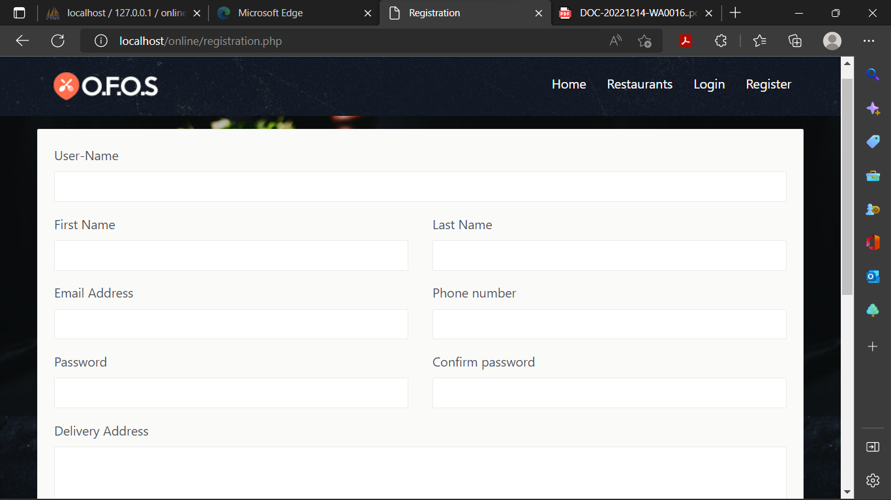

**<!DOCTYPE html>**

**<html lang="en">**

**<?php**

**session_start();**

**error_reporting(0);**

**include("connection/connect.php");**

**if(isset($_POST['submit'] ))**

**{ if(empty($_POST['firstname']) || empty($_POST['lastname'])||**

**empty($_POST['email']) || empty($_POST['phone'])||**

**empty($_POST['password'])||empty($_POST['cpassword']) ||**

**empty($_POST['cpassword'])){**

**$message = "All fields must be Required!";}**

**else{$check_username= mysqli_query($db, "SELECT username FROM users where username = '".$_POST['username']."' ");**

**$check_email = mysqli_query($db, "SELECT email FROM users where email = '".$_POST['email']."' ");**

**if($_POST['password'] != $_POST['cpassword']){**

**echo "<script>alert('Password not match');</script>";**

**}**

**elseif(strlen($_POST['password']) < 6) {**

**echo "<script>alert('Password Must be >=6');</script>";**

**}**

**elseif(strlen($_POST['phone']) < 10) {**

**echo "<script>alert('Invalid phone number!');</script>";**

**}**

**elseif (!filter_var($_POST['email'], FILTER_VALIDATE_EMAIL)) {**

**echo "<script>alert('Invalid email address please type a valid email!');</script>";**

**}**

**elseif(mysqli_num_rows($check_username) > 0) {**

**echo "<script>alert('Username Already exists!');</script>";**

**}**

**elseif(mysqli_num_rows($check_email) > 0) {**

**echo "<script>alert('Email Already exists!');</script>";**

**}**

**else{**

**$mql = "INSERT INTO users(username,f_name,l_name,email,phone,password,address) VALUES('".$_POST['username']."','".$_POST['firstname']."','".$_POST['lastname']."','".$_POST['email']."','".$_POST['phone']."','".md5($_POST['password'])."','".$_POST['address']."')";**

**mysqli_query($db, $mql);**

**header("refresh:0.1;url=login.php");**

**}}}**

**?>**

**<head>**

**<meta charset="utf-8">**

**<meta http-equiv="X-UA-Compatible" content="IE=edge">**

**<meta name="viewport" content="width=device-width, initial-scale=1, shrink-to-fit=no">**

**<meta name="description" content="">**

**<meta name="author" content="">**

**<link rel="icon" href="#">**

**<title>Registration</title>**

**<link href="css/bootstrap.min.css" rel="stylesheet">**

**<link href="css/font-awesome.min.css" rel="stylesheet">**

**<link href="css/animsition.min.css" rel="stylesheet">**

**<link href="css/animate.css" rel="stylesheet">**

**<link href="css/style.css" rel="stylesheet"> </head>**

**<body>**

**<div style=" background-image: url('images/img/pimg.jpg');">**

**<header id="header" class="header-scroll top-header headrom">**

**<nav class="navbar navbar-dark">**

**<div class="container">**

**<button class="navbar-toggler hidden-lg-up" type="button" data-toggle="collapse" data-target="#mainNavbarCollapse">&#9776;</button>**

**<a class="navbar-brand" href="index.php"> <img class="img-rounded" src="images/icn.png" alt=""> </a>**

**<div class="collapse navbar-toggleable-md float-lg-right" id="mainNavbarCollapse">**

**<ul class="nav navbar-nav">**

**<li class="nav-item"> <a class="nav-link active" href="index.php">Home <span class="sr-only">(current)</span></a> </li>**

**<li class="nav-item"> <a class="nav-link active" href="restaurants.php">Restaurants <span class="sr-only"></span></a> </li> <?php if(empty($_SESSION["user_id"])){**

**echo '<li class="nav-item"><a href="login.php" class="nav-link active">Login</a> </li>**

**<li class="nav-item"><a href="registration.php" class="nav-link active">Register</a> </li>';}else{**

**echo '<li class="nav-item"><a href="your_orders.php" class="nav-link active">My Orders</a> </li>';**

**echo '<li class="nav-item"><a href="logout.php" class="nav-link active">Logout</a> </li>';}?>**

**</ul>**

**</div></div></nav>**

**</header>**

**<div class="page-wrapper">**

**<div class="container">**

**<ul></ul>**

**</div>**

**<section class="contact-page inner-page">**

**<div class="container ">**

**<div class="row ">**

**<div class="col-md-12">**

**<div class="widget" >**

**<div class="widget-body">**

**<form action="" method="post">**

**<div class="row"> <div class="form-group col-sm-12">**

**<label for="exampleInputEmail1">User-Name</label>**

**<input class="form-control" type="text" name="username" id="example-text-input">**

**</div>**

**<div class="form-group col-sm-6">**

**<label for="exampleInputEmail1">First Name</label>**

**<input class="form-control" type="text" name="firstname" id="example-text-input"> </div>**

**<div class="form-group col-sm-6">**

**<label for="exampleInputEmail1">Last Name</label>**

**<input class="form-control" type="text" name="lastname" id="example-text-input-2"> </div>**

**<div class="form-group col-sm-6">**

**<label for="exampleInputEmail1">Email Address</label>**

**<input type="text" class="form-control" name="email" id="exampleInputEmail1" aria-describedby="emailHelp">**

**</div>**

**<div class="form-group col-sm-6">**

**<label for="exampleInputEmail1">Phone number</label>**

**<input class="form-control" type="text" name="phone" id="example-tel-input-3"> </div>**

**<div class="form-group col-sm-6">**

**<label for="exampleInputPassword1">Password</label>**

**<input type="password" class="form-control" name="password" id="exampleInputPassword1">**

**</div>**

**<div class="form-group col-sm-6">**

**<label for="exampleInputPassword1">Confirm password</label>**

**<input type="password" class="form-control" name="cpassword" id="exampleInputPassword2">**

**</div><div class="form-group col-sm-12">**

**<label for="exampleTextarea">Delivery Address</label>**

**<textarea class="form-control" id="exampleTextarea" name="address" rows="3"></textarea>**

**</div> </div>**

**<div class="row">**

**<div class="col-sm-4">**

**<p> <input type="submit" value="Register" name="submit" class="btn theme-btn"> </p>**

**</div> </div>**

**</form> </div>**

**</div></div>**

**</div>**

**</div>**

**</section>**

**<footer class="footer">**

**<div class="container"><div class="row bottom-footer">**

**<div class="container">**

**<div class="row">**

**<div class="col-xs-12 col-sm-3 payment-options color-gray">**

**<h5>Payment Options</h5>**

**<ul>**

**<li>**

**<a href="#"> <img src="images/paypal.png" alt="Paypal"> </a></li>**

**<li>**

**<a href="#"> <img src="images/mastercard.png" alt="Mastercard"> </a>**

**</li> <li><a href="#"> <img src="images/maestro.png" alt="Maestro"> </a></l><li>**

**<a href="#"> <img src="images/stripe.png" alt="Stripe"> </a> </li>**

**<li>**

**<a href="#"> <img src="images/bitcoin.png" alt="Bitcoin"> </a>**

**</li> </ul> </div>**

**<div class="col-xs-12 col-sm-4 address color-gray">**

**<h5>NAME</h5>**

**<p>Edrich Ryan Cardozo </p>**

**<h5>Roll number: 20CE21</a></h5> </div>**

**<div class="col-xs-12 col-sm-5 additional-info color-gray">**

**<h5>Addition informations</h5>**

**<p>Online Food Ordering DBMS project by 20CE21.</p>**

**</div>**

**</div> </div></div>**

**</div>**

**</footer>**

**</div>**

**<script src="js/jquery.min.js"></script>**

**<script src="js/tether.min.js"></script>**

**<script src="js/bootstrap.min.js"></script>**

**<script src="js/animsition.min.js"></script>**

**<script src="js/bootstrap-slider.min.js"></script>**

**<script src="js/jquery.isotope.min.js"></script>**

**<script src="js/headroom.js"></script>**

**<script src="js/foodpicky.min.js"></script>**

**</body>**

**</html>**

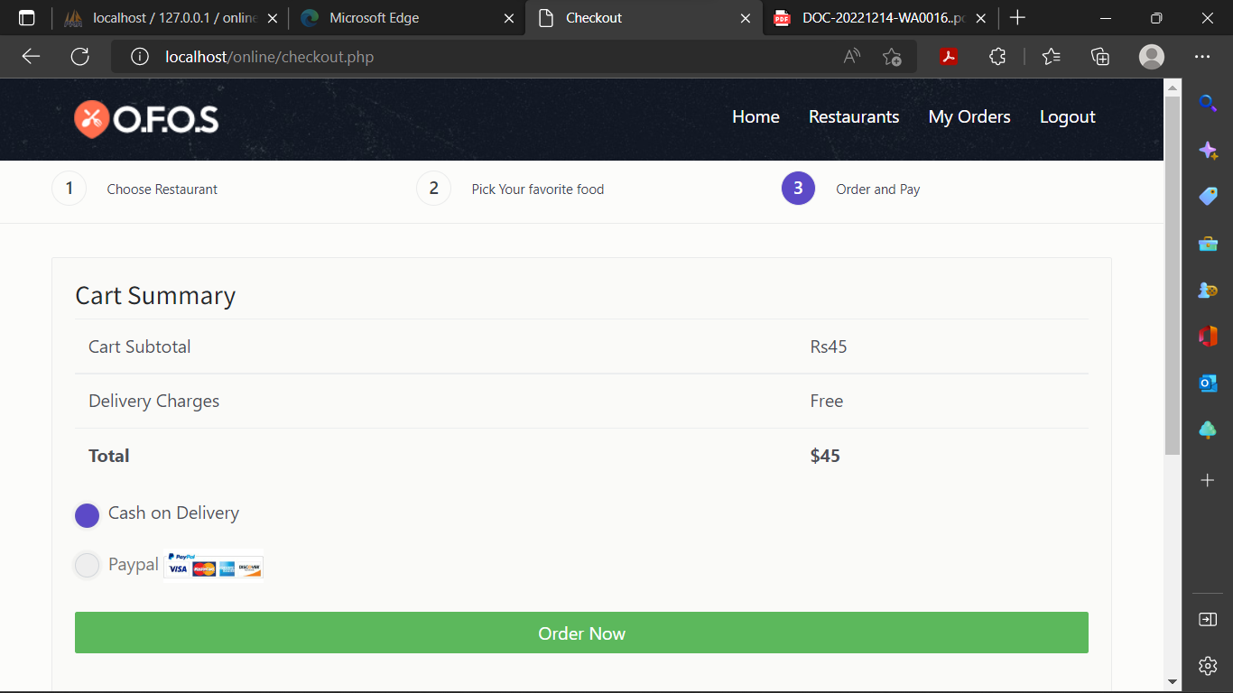

**Checkout,php**

**<!DOCTYPE html>**

**<html lang="en">**

**<?php**

**include("connection/connect.php");**

**include_once 'product-action.php';**

**error_reporting(0);**

**session_start();**

**function function_alert() {**

**echo "<script>alert('Thank you. Your Order has been placed!');</script>";**

**echo "<script>window.location.replace('your_orders.php');</script>";**

**}**

**if(empty($_SESSION["user_id"])){**

**header('location:login.php');**

**}**

**else{**

**foreach ($_SESSION["cart_item"] as $item){ $item_total += ($item["price"]*$item["quantity"]); if($_POST['submit']){ $SQL="insert into users_orders(u_id,title,quantity,price) values('".$_SESSION["user_id"]."','".$item["title"]."','".$item["quantity"]."','".$item["price"]."')"; mysqli_query($db,$SQL);**

**unset($_SESSION["cart_item"]);**

**unset($item["title"]);**

**unset($item["quantity"]);**

**unset($item["price"]); $success = "Thank you. Your order has been placed!";**

**function_alert();**

**}}**

**?>**

**<head>**

**<meta charset="utf-8">**

**<meta http-equiv="X-UA-Compatible" content="IE=edge">**

**<meta name="viewport" content="width=device-width, initial-scale=1, shrink-to-fit=no">**

**<meta name="description" content="">**

**<meta name="author" content="">**

**<link rel="icon" href="#">**

**<title>Checkout</title>**

**<link href="css/bootstrap.min.css" rel="stylesheet">**

**<link href="css/font-awesome.min.css" rel="stylesheet">**

**<link href="css/animsition.min.css" rel="stylesheet">**

**<link href="css/animate.css" rel="stylesheet">**

**<link href="css/style.css" rel="stylesheet"> </head>**

**<body>**

**<div class="site-wrapper">**

**<header id="header" class="header-scroll top-header headrom">**

**<nav class="navbar navbar-dark">**

**<div class="container">**

**<button class="navbar-toggler hidden-lg-up" type="button" data-toggle="collapse" data-target="#mainNavbarCollapse">&#9776;</button>**

**<a class="navbar-brand" href="index.php"> <img class="img-rounded" src="images/icn.png" alt=""> </a>**

**<div class="collapse navbar-toggleable-md float-lg-right" id="mainNavbarCollapse">**

**<ul class="nav navbar-nav">**

**<li class="nav-item"> <a class="nav-link active" href="index.php">Home <span class="sr-only">(current)</span></a> </li>**

**<li class="nav-item"> <a class="nav-link active" href="restaurants.php">Restaurants <span class="sr-only"></span></a> </li>**

**<?php**

**if(empty($_SESSION["user_id"]))**

**{**

**echo '<li class="nav-item"><a href="login.php" class="nav-link active">Login</a> </li>**

**<li class="nav-item"><a href="registration.php" class="nav-link active">Register</a> </li>';**

**}**

**else{echo '<li class="nav-item"><a href="your_orders.php" class="nav-link active">My Orders</a> </li>';**

**echo '<li class="nav-item"><a href="logout.php" class="nav-link active">Logout</a> </li>';**

**}**

**?>**

**</ul> </div>**

**</div>**

**</nav>**

**</header>**

**<div class="page-wrapper">**

**<div class="top-links">**

**<div class="container">**

**<ul class="row links">**

**<li class="col-xs-12 col-sm-4 link-item"><span>1</span><a href="restaurants.php">Choose Restaurant</a></li>**

**<li class="col-xs-12 col-sm-4 link-item "><span>2</span><a href="#">Pick Your favorite food</a></li>**

**<li class="col-xs-12 col-sm-4 link-item active" ><span>3</span><a href="checkout.php">Order and Pay</a></li>**

**</ul>**

**</div>**

**</div>**

**<div class="container">**

**<span style="color:green;">**

**<?php echo $success; ?>**

**</span>**

**</div>**

**<div class="container m-t-30">**

**<form action="" method="post">**

**<div class="widget clearfix">**

**<div class="widget-body">**

**<form method="post" action="#">**

**<div class="row">**

**<div class="col-sm-12">**

**<div class="cart-totals margin-b-20">**

**<div class="cart-totals-title">**

**<h4>Cart Summary</h4> </div>**

**<div class="cart-totals-fields">**

**<table class="table"><tbody>**

**<tr>**

**<td>Cart Subtotal</td>**

**<td> <?php echo "Rs".$item_total; ?></td>**

**</tr>**

**<tr>**

**<td>Delivery Charges</td>**

**<td>Free</td>**

**</tr>**

**<tr>**

**<td class="text-color"><strong>Total</strong></td>**

**<td class="text-color"><strong> <?php echo "$".$item_total; ?></strong></td>**

**</tr>**

**</tbody>**

**</table>**

**</div>**

**</div>**

**<div class="payment-option">**

**<ul class=" list-unstyled">**

**<li>**

**<label class="custom-control custom-radio m-b-20">**

**<input name="mod" id="radioStacked1" checked value="COD" type="radio" class="custom-control-input"> <span class="custom-control-indicator"></span> <span class="custom-control-description">Cash on Delivery</span>**

**</label>**

**</li>**

**<li>**

**<label class="custom-control custom-radio m-b-10">**

**<input name="mod" type="radio" value="paypal" disabled class="custom-control-input"> <span class="custom-control-indicator"></span> <span class="custom-control-description">Paypal <img src="images/paypal.jpg" alt="" width="90"></span> </label>**

**</li>**

**</ul>**

**<p class="text-xs-center"> <input type="submit" onclick="return confirm('Do you want to confirm the order?');" name="submit" class="btn btn-success btn-block" value="Order Now"> </p>**

**</div>**

**</form>**

**</div>**

**</div>**

**</div>**

**</div>**

**</form>**

**</div>**

**</div>**

**</div>**

**<script src="js/jquery.min.js"></script>**

**<script src="js/tether.min.js"></script>**

**<script src="js/bootstrap.min.js"></script>**

**<script src="js/animsition.min.js"></script>**

**<script src="js/bootstrap-slider.min.js"></script>**

**<script src="js/jquery.isotope.min.js"></script>**

**<script src="js/headroom.js"></script>**

**<script src="js/foodpicky.min.js"></script>**

**</body>**

**</html>**

**<?php**

**}**

**?>**

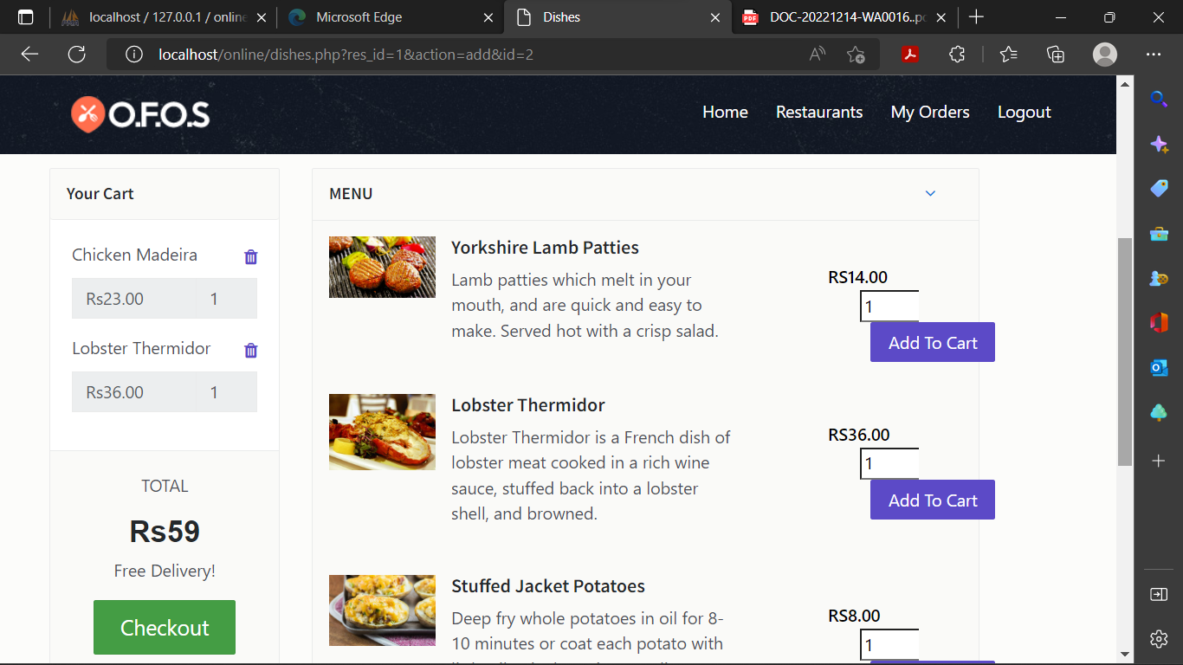

**Delete_orders.php**

**<?php**

**include("connection/connect.php"); //connection to db**

**error_reporting(0);**

**session_start();**

**// sending query**

**mysqli_query($db,"DELETE FROM users_orders WHERE o_id = '".$_GET['order_del']."'");**

**header("location:your_orders.php");**

**?>**

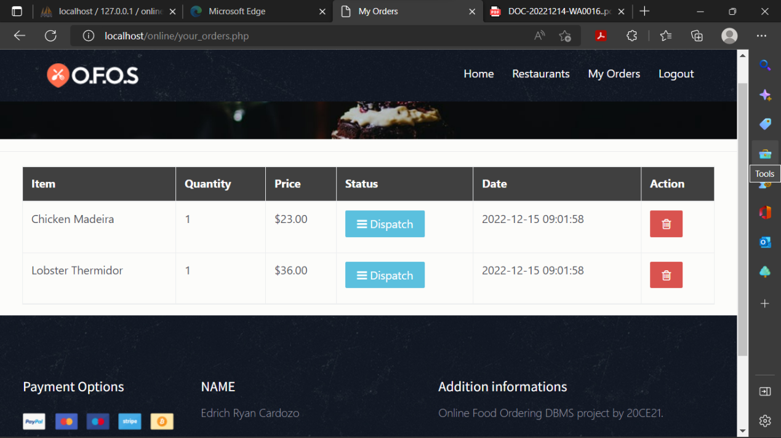

**Your_orders.php**

**<!DOCTYPE html>**

**<html lang="en">**

**<?php**

**include("connection/connect.php");**

**error_reporting(0);**

**session_start();**

**if(empty($_SESSION['user_id'])) {**

**header('location:login.php');**

**}**

**else{**

**?>**

**<head>**

**<meta charset="utf-8">**

**<meta http-equiv="X-UA-Compatible" content="IE=edge">**

**<meta name="viewport" content="width=device-width, initial-scale=1, shrink-to-fit=no">**

**<meta name="description" content="">**

**<meta name="author" content="">**

**<link rel="icon" href="#">**

**<title>My Orders</title>**

**<link href="css/bootstrap.min.css" rel="stylesheet">**

**<link href="css/font-awesome.min.css" rel="stylesheet">**

**<link href="css/animsition.min.css" rel="stylesheet">**

**<link href="css/animate.css" rel="stylesheet">**

**<link href="css/style.css" rel="stylesheet">**

**<style type="text/css" rel="stylesheet">**

**.indent-small {**

**margin-left: 5px;**

**}**

**.form-group.internal {**

**margin-bottom: 0;**

**}**

**.dialog-panel {**

**margin: 10px;**

**}**

**.datepicker-dropdown {**

**z-index: 200 !important;**

**}**

**.panel-body {**

**background: #e5e5e5;**

**/* Old browsers */**

**background: -moz-radial-gradient(center, ellipse cover, #e5e5e5 0%, #ffffff 100%);**

**/* FF3.6+ */**

**background: -webkit-gradient(radial, center center, 0px, center center, 100%, color-stop(0%, #e5e5e5), color-stop(100%, #ffffff));**

**/* Chrome,Safari4+ */**

**background: -webkit-radial-gradient(center, ellipse cover, #e5e5e5 0%, #ffffff 100%);**

**/* Chrome10+,Safari5.1+ */**

**background: -o-radial-gradient(center, ellipse cover, #e5e5e5 0%, #ffffff 100%);**

**/* Opera 12+ */**

**background: -ms-radial-gradient(center, ellipse cover, #e5e5e5 0%, #ffffff 100%);**

**/* IE10+ */**

**background: radial-gradient(ellipse at center, #e5e5e5 0%, #ffffff 100%);**

**/* W3C */**

**filter: progid:DXImageTransform.Microsoft.gradient(startColorstr='#e5e5e5', endColorstr='#ffffff', GradientType=1);**

**font: 600 15px "Open Sans", Arial, sans-serif;**

**}**

**label.control-label {**

**font-weight: 600;**

**color: #777;**

**}**

**/\***

**table {**

**width: 750px;**

**border-collapse: collapse;**

**margin: auto; }**

**/* Zebra striping */**

**/* tr:nth-of-type(odd) {**

**background: #eee; }**

**th {**

**background: #404040;**

**color: white;**

**font-weight: bold; }**

**td, th {**

**padding: 10px;**

**border: 1px solid #ccc;**

**text-align: left;**

**font-size: 14px;}**

**@media**

**only screen and (max-width: 760px),**

**(min-device-width: 768px) and (max-device-width: 1024px) {**

**/* table {**

**width: 100%; }**

**table, thead, tbody, th, td, tr {**

**display: block;} */**

**/* thead tr {**

**position: absolute;**

**top: -9999px;**

**left: -9999px; }**

**tr { border: 1px solid #ccc; } */**

**/* td {**

**border: none;**

**border-bottom: 1px solid #eee;**

**position: relative;**

**padding-left: 50%; }**

**td:before {**

**position: absolute;**

**top: 6px;**

**left: 6px;**

**width: 45%;**

**padding-right: 10px;**

**white-space: nowrap;**

**content: attr(data-column);**

**color: #000;**

**font-weight: bold;} */**

**}**

**</style>**

**</head>**

**<body>**

**<header id="header" class="header-scroll top-header headrom">**

**<nav class="navbar navbar-dark">**

**<div class="container">**

**<button class="navbar-toggler hidden-lg-up" type="button" data-toggle="collapse" data-target="#mainNavbarCollapse">&#9776;</button>**

**<a class="navbar-brand" href="index.php"> <img class="img-rounded" src="images/icn.png" alt=""> </a>**

**<div class="collapse navbar-toggleable-md float-lg-right" id="mainNavbarCollapse">**

**<ul class="nav navbar-nav">**

**<li class="nav-item"> <a class="nav-link active" href="index.php">Home <span class="sr-only">(current)</span></a> </li>**

**<li class="nav-item"> <a class="nav-link active" href="restaurants.php">Restaurants <span class="sr-only"></span></a> </li> <?php**

**if(empty($_SESSION["user_id"])) {**

**echo '<li class="nav-item"><a href="login.php" class="nav-link active">Login</a> </li>**

**<li class="nav-item"><a href="registration.php" class="nav-link active">Register</a> </li>';}**

**else{**

**echo '<li class="nav-item"><a href="your_orders.php" class="nav-link active">My Orders</a> </li>';**

**echo '<li class="nav-item"><a href="logout.php" class="nav-link active">Logout</a> </li>';}?>**

**</ul>**

**</div>**

**</div></nav>**

**</header>**

**<div class="page-wrapper">**

**<div class="inner-page-hero bg-image" data-image-src="images/img/pimg.jpg">**

**<div class="container"> </div>**

**</div>**

**<div class="result-show">**

**<div class="container">**

**<div class="row">**

**</div>**

**</div>**

**</div>**

**<section class="restaurants-page">**

**<div class="container">**

**<div class="row">**

**<div class="col-xs-12">**

**</div>**

**<div class="col-xs-12">**

**<div class="bg-gray">**

**<div class="row">**

**<table class="table table-bordered table-hover">**

**<thead style = "background: #404040; color:white;">**

**<tr>**

**<th>Item</th>**

**<th>Quantity</th>**

**<th>Price</th>**

**<th>Status</th> <th>Date</th> <th>Action</th>**

**</tr> </thead> <tbody><?php**

**$query_res= mysqli_query($db,"select * from users_orders where u_id='".$_SESSION['user_id']."'"); if(!mysqli_num_rows($query_res) > 0 ){**

**echo '<td colspan="6"><center>You have No orders Placed yet. </center></td>';} else{**

**while($row=mysqli_fetch_array($query_res)){**

**?> <tr> <td data-column="Item"> <?php echo $row['title']; ?></td>**

**<td data-column="Quantity"> <?php echo $row['quantity']; ?></td>**

**<td data-column="price">$<?php echo $row['price']; ?></td>**

**<td data-column="status"> <?php $status=$row['status']; if($status=="" or $status=="NULL"){ ?>**

**<button type="button" class="btn btn-info"><span class="fa fa-bars" aria-hidden="true" ></span> Dispatch</button>**

**<?php }**

**if($status=="in process") { ?>**

**<button type="button" class="btn btn-warning"><span class="fa fa-cog fa-spin" aria-hidden="true" ></span> On The Way!</button>**

**<?php**

**}if($status=="closed"){?>**

**<button type="button" class="btn btn-success" ><span class="fa fa-check-circle" aria-hidden="true"></span> Delivered</button><?php }**

**?><?phpif($status=="rejected"){ ?> <button type="button" class="btn btn-danger"> <i class="fa fa-close"></i> Cancelled</button><?php } ?>**

**</td><td data-column="Date"> <?php echo $row['date']; ?></td>**

**<td data-column="Action"> <a href="delete_orders.php?order_del=<?php echo $row['o_id'];?>" onclick="return confirm('Are you sure you want to cancel your order?');" class="btn btn-danger btn-flat btn-addon btn-xs m-b-10"><i class="fa fa-trash-o" style="font-size:16px"></i></a> </td></tr><?php }} ?> </tbody>**

**</table></div>**

**</div>**

**</div>**

**</div></div>**

**</div>**

**</section>**

**</div>**

**<script src="js/jquery.min.js"></script>**

**<script src="js/tether.min.js"></script>**

**<script src="js/bootstrap.min.js"></script>**

**<script src="js/animsition.min.js"></script>**

**<script src="js/bootstrap-slider.min.js"></script>**

**<script src="js/jquery.isotope.min.js"></script>**

**<script src="js/headroom.js"></script>**

**<script src="js/foodpicky.min.js"></script>**

**</body>**

**</html>**

**<?php**

**}**

**Logout.php**

**<?php**

**session_start();**

**session_destroy();**

**$url = 'login.php';**

**header('Location: ' . $url);**

**?>**

**Product-action.php**

**<?php**

**if(!empty($_GET["action"])) {**

**$productId = isset($_GET['id']) ? htmlspecialchars($_GET['id']) : '';**

**$quantity = isset($_POST['quantity']) ? htmlspecialchars($_POST['quantity']) : '';**

**switch($_GET["action"]) {**

**case "add":**

**if(!empty($quantity)) {**

**$stmt = $db->prepare("SELECT * FROM dishes where d_id= ?");**

**$stmt->bind_param('i',$productId);**

**$stmt->execute();**

**$productDetails = $stmt->get_result()->fetch_object();**

**$itemArray = array($productDetails->d_id=>array('title'=>$productDetails->title, 'd_id'=>$productDetails->d_id, 'quantity'=>$quantity, 'price'=>$productDetails->price));**

**if(!empty($_SESSION["cart_item"])){**

**if(in_array($productDetails->d_id,array_keys($_SESSION["cart_item"]))) {**

**foreach($_SESSION["cart_item"] as $k => $v) {**

**if($productDetails->d_id == $k){**

**if(empty($_SESSION["cart_item"][$k]["quantity"])) {**

**$_SESSION["cart_item"][$k]["quantity"] = 0;}**

**$_SESSION["cart_item"][$k]["quantity"] += $quantity;**

**}}}**

**else {**

**$_SESSION["cart_item"] = $_SESSION["cart_item"] + $itemArray;}}**

**else {**

**$_SESSION["cart_item"] = $itemArray;**

**}}break;**

**case "remove":**

**if(!empty($_SESSION["cart_item"])){**

**foreach($_SESSION["cart_item"] as $k => $v) {**

**if($productId == $v['d_id'])**

**unset($_SESSION["cart_item"][$k]);**

**}}break;**

**case "empty":**

**unset($_SESSION["cart_item"]);**

**break;**

**case "check":**

**header("location:checkout.php");**

**break;**

**}**

**}**

**Admin panel:**

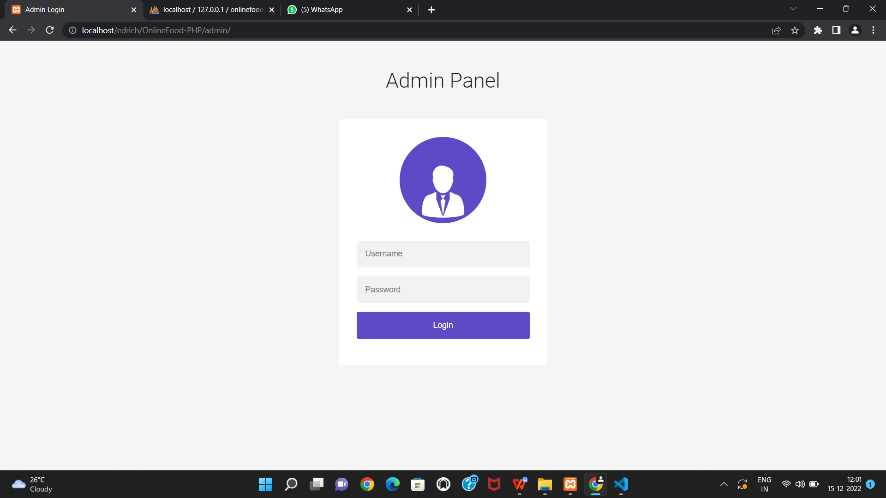

<!DOCTYPE html>

<html lang="en" >

<?php

include("../connection/connect.php");

error_reporting(0);

session_start();

if(isset($_POST['submit']))

{

$username = $_POST['username'];

$password = $_POST['password'];

if(!empty($_POST["submit"]))

{

$loginquery ="SELECT * FROM admin WHERE username='$username' && password='".md5($password)."'";

$result=mysqli_query($db, $loginquery);

$row=mysqli_fetch_array($result);

if(is_array($row))

{

$_SESSION["adm_id"] = $row['adm_id'];

header("refresh:1;url=dashboard.php");

}

else

{

echo "<script>alert('Invalid Username or Password!');</script>";

}

}

}

?>

<head>

<meta charset="UTF-8">

<title>Admin Login</title>

<link rel="stylesheet" href="https://cdnjs.cloudflare.com/ajax/libs/meyer-reset/2.0/reset.min.css">

<link rel='stylesheet prefetch' href='https://fonts.googleapis.com/css?family=Roboto:400,100,300,500,700,900'>

<link rel='stylesheet prefetch' href='https://fonts.googleapis.com/css?family=Montserrat:400,700'>

<link rel='stylesheet prefetch' href='https://maxcdn.bootstrapcdn.com/font-awesome/4.3.0/css/font-awesome.min.css'>

<link rel="stylesheet" href="css/login.css">

</head>

<body>

<div class="container">

<div class="info">

<h1>Admin Panel </h1>

</div>

</div>

<div class="form">

<div class="thumbnail"><img src="images/manager.png"/></div>

<span style="color:red;"><?php echo $message; ?></span>

<span style="color:green;"><?php echo $success; ?></span>

<form class="login-form" action="index.php" method="post">

<input type="text" placeholder="Username" name="username"/>

<input type="password" placeholder="Password" name="password"/>

<input type="submit" name="submit" value="Login" />

</form>

</div>

<script src='http://cdnjs.cloudflare.com/ajax/libs/jquery/2.1.3/jquery.min.js'></script>

<script src='js/index.js'></script>

</body>

</html>

Dashboard:

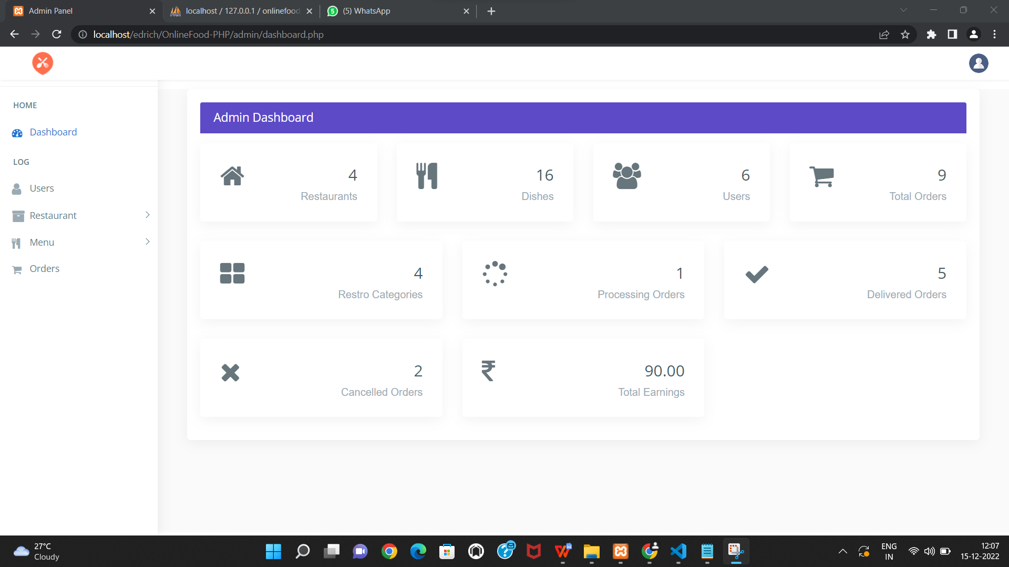

User details:

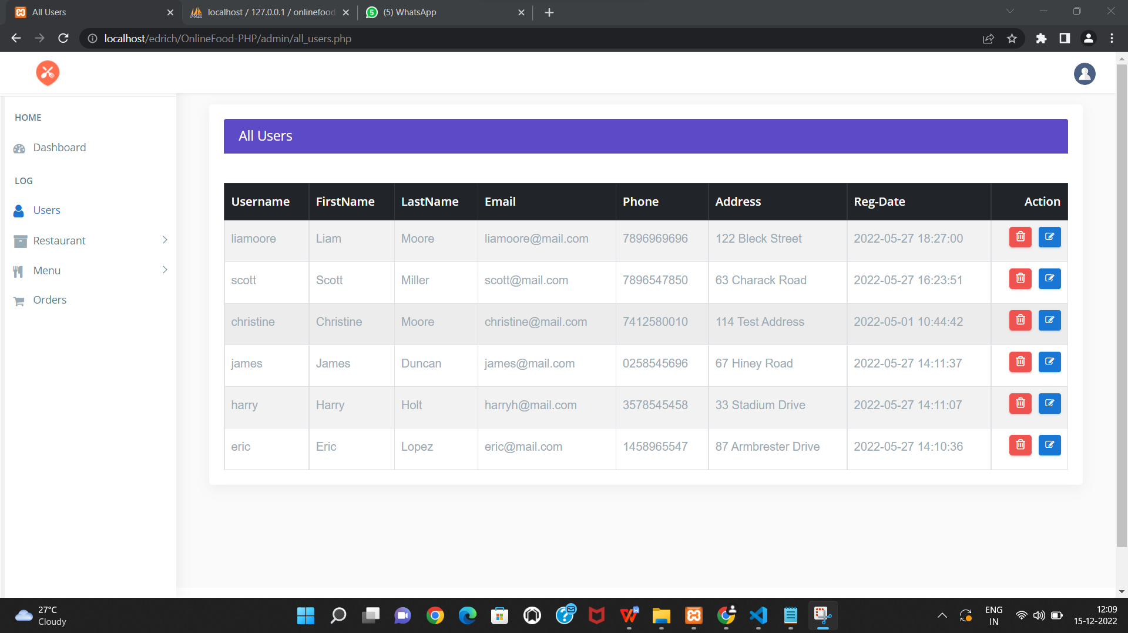

<!DOCTYPE html>

<html lang="en">

<?php

include("../connection/connect.php");

error_reporting(0);

session_start();

?>

<head>

<meta charset="utf-8">

<meta http-equiv="X-UA-Compatible" content="IE=edge">

<meta name="viewport" content="width=device-width, initial-scale=1">

<meta name="description" content="">

<meta name="author" content="">

<title>All Users</title>

<link href="css/lib/bootstrap/bootstrap.min.css" rel="stylesheet">

<link href="css/helper.css" rel="stylesheet">

<link href="css/style.css" rel="stylesheet">

</head>

<body class="fix-header fix-sidebar">

<div class="preloader">

<svg class="circular" viewBox="25 25 50 50">

<circle class="path" cx="50" cy="50" r="20" fill="none" stroke-width="2" stroke-miterlimit="10" /> </svg>

</div>

<div id="main-wrapper">

<div class="header">

<nav class="navbar top-navbar navbar-expand-md navbar-light">

<div class="navbar-header">

<a class="navbar-brand" href="dashboard.php">

<span><img src="images/icn.png" alt="homepage" class="dark-logo" /></span>

</a>

</div>

<div class="navbar-collapse">

<ul class="navbar-nav mr-auto mt-md-0">

</ul>

<ul class="navbar-nav my-lg-0">

<li class="nav-item dropdown">

<div class="dropdown-menu dropdown-menu-right mailbox animated zoomIn">

<ul>

<li>

<div class="drop-title">Notifications</div>

</li>

<li>

<a class="nav-link text-center" href="javascript:void(0);"> <strong>Check all notifications</strong> <i class="fa fa-angle-right"></i> </a>

</li>

</ul>

</div>

</li>

<li class="nav-item dropdown">

<a class="nav-link dropdown-toggle text-muted " href="#" data-toggle="dropdown" aria-haspopup="true" aria-expanded="false"><img src="images/bookingSystem/user-icn.png" alt="user" class="profile-pic" /></a>

<div class="dropdown-menu dropdown-menu-right animated zoomIn">

<ul class="dropdown-user">

<li><a href="logout.php"><i class="fa fa-power-off"></i> Logout</a></li>

</ul>

</div>

</li>

</ul>

</div>

</nav>

</div>

<div class="left-sidebar">

<div class="scroll-sidebar">

<nav class="sidebar-nav">

<ul id="sidebarnav">

<li class="nav-devider"></li>

<li class="nav-label">Home</li>

<li> <a href="dashboard.php"><i class="fa fa-tachometer"></i><span>Dashboard</span></a></li>

<li class="nav-label">Log</li>

<li> <a href="all_users.php"> <span><i class="fa fa-user f-s-20 "></i></span><span>Users</span></a></li>

<li> <a class="has-arrow " href="#" aria-expanded="false"><i class="fa fa-archive f-s-20 color-warning"></i><span class="hide-menu">Restaurant</span></a>

<ul aria-expanded="false" class="collapse">

<li><a href="all_restaurant.php">All Restaurants</a></li>

<li><a href="add_category.php">Add Category</a></li>

<li><a href="add_restaurant.php">Add Restaurant</a></li>

</ul>

</li>

<li> <a class="has-arrow " href="#" aria-expanded="false"><i class="fa fa-cutlery" aria-hidden="true"></i><span class="hide-menu">Menu</span></a>

<ul aria-expanded="false" class="collapse">

<li><a href="all_menu.php">All Menues</a></li>

<li><a href="add_menu.php">Add Menu</a></li>

</ul>

</li>

<li> <a href="all_orders.php"><i class="fa fa-shopping-cart" aria-hidden="true"></i><span>Orders</span></a></li>

</ul>

</nav>

</div>

</div>

<div class="page-wrapper">

<div class="container-fluid">

<div class="row">

<div class="col-12">

<div class="col-lg-12">

<div class="card card-outline-primary">

<div class="card-header">

<h4 class="m-b-0 text-white">All Users</h4>

</div>

<div class="table-responsive m-t-40">

<table id="myTable" class="table table-bordered table-striped table-hover">

<thead class="thead-dark">

<tr>

<th>Username</th>

<th>FirstName</th>

<th>LastName</th>

<th>Email</th>

<th>Phone</th>

<th>Address</th>

<th>Reg-Date</th>

<th>Action</th>

</tr>

</thead>

<tbody>

<?php

$sql="SELECT * FROM users order by u_id desc";

$query=mysqli_query($db,$sql);

if(!mysqli_num_rows($query) > 0 )

{

echo '<td colspan="7"><center>No Users</center></td>';

}

else

{

while($rows=mysqli_fetch_array($query))

{

echo ' <tr><td>'.$rows['username'].'</td>

<td>'.$rows['f_name'].'</td>

<td>'.$rows['l_name'].'</td>

<td>'.$rows['email'].'</td>

<td>'.$rows['phone'].'</td>

<td>'.$rows['address'].'</td>

<td>'.$rows['date'].'</td>

<td><a href="delete_users.php?user_del='.$rows['u_id'].'" class="btn btn-danger btn-flat btn-addon btn-xs m-b-10"><i class="fa fa-trash-o" style="font-size:16px"></i></a>

<a href="update_users.php?user_upd='.$rows['u_id'].'" " class="btn btn-info btn-flat btn-addon btn-sm m-b-10 m-l-5"><i class="fa fa-edit"></i></a>

</td></tr>';

}

}

?>

</tbody>

</table>

</div>

</div>

</div>

</div>

</div>

</div>

</div>

</div>

</div>

<footer class="footer">Online Food Ordering System by Edrich Ryan Cardozo </footer>

</div>

</div>

<script src="js/lib/jquery/jquery.min.js"></script>>

<script src="js/lib/bootstrap/js/popper.min.js"></script>

<script src="js/lib/bootstrap/js/bootstrap.min.js"></script>

<script src="js/jquery.slimscroll.js"></script>

<script src="js/sidebarmenu.js"></script>

<script src="js/lib/sticky-kit-master/dist/sticky-kit.min.js"></script>

<script src="js/custom.min.js"></script>

</body>

</html>

All restuarants:

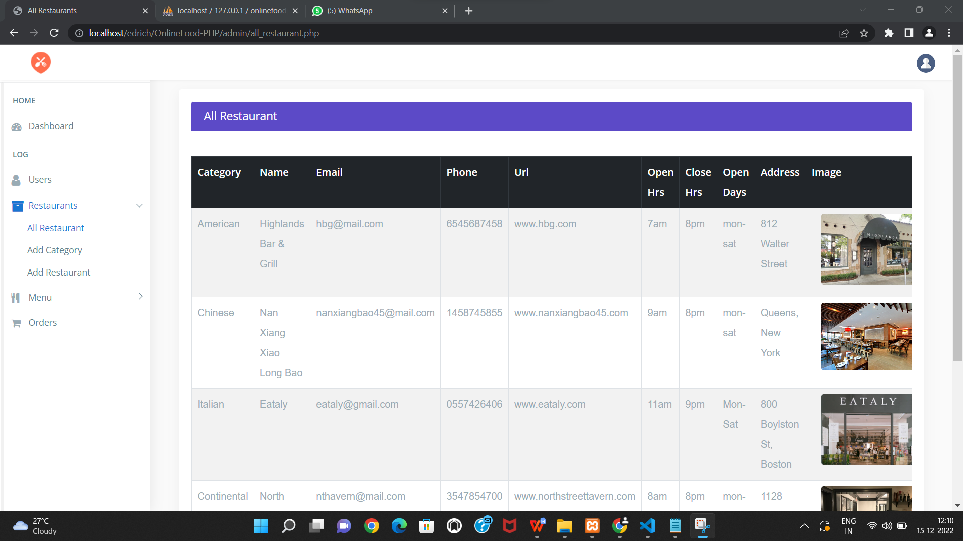

<!DOCTYPE html>

<html lang="en">

<?php

include("../connection/connect.php");

error_reporting(0);

session_start();

?>

<head>

<meta charset="utf-8">

<meta http-equiv="X-UA-Compatible" content="IE=edge">

<meta name="viewport" content="width=device-width, initial-scale=1">

<meta name="description" content="">

<meta name="author" content="">

<link rel="icon" type="image/png" sizes="16x16" href="images/favicon.png">

<title>All Restaurants</title>

<link href="css/lib/bootstrap/bootstrap.min.css" rel="stylesheet">

<link href="css/helper.css" rel="stylesheet">

<link href="css/style.css" rel="stylesheet">

</head>

<body class="fix-header fix-sidebar">

<div class="preloader">

<svg class="circular" viewBox="25 25 50 50">

<circle class="path" cx="50" cy="50" r="20" fill="none" stroke-width="2" stroke-miterlimit="10" /> </svg>

</div>

<div id="main-wrapper">

<div class="header">

<nav class="navbar top-navbar navbar-expand-md navbar-light">

<div class="navbar-header">

<a class="navbar-brand" href="dashboard.php">

<span><img src="images/icn.png" alt="homepage" class="dark-logo" /></span>

</a>

</div>

<div class="navbar-collapse">

<ul class="navbar-nav mr-auto mt-md-0">

</ul>

<ul class="navbar-nav my-lg-0">

<li class="nav-item dropdown">

<div class="dropdown-menu dropdown-menu-right mailbox animated zoomIn">

<ul>

<li>

<div class="drop-title">Notifications</div>

</li>

<li>

<a class="nav-link text-center" href="javascript:void(0);"> <strong>Check all notifications</strong> <i class="fa fa-angle-right"></i> </a>

</li>

</ul>

</div>

</li>

<li class="nav-item dropdown">

<a class="nav-link dropdown-toggle text-muted " href="#" data-toggle="dropdown" aria-haspopup="true" aria-expanded="false"><img src="images/bookingSystem/user-icn.png" alt="user" class="profile-pic" /></a>

<div class="dropdown-menu dropdown-menu-right animated zoomIn">

<ul class="dropdown-user">

<li><a href="logout.php"><i class="fa fa-power-off"></i> Logout</a></li>

</ul>

</div>

</li>

</ul>

</div>

</nav>

</div>

<div class="left-sidebar">

<div class="scroll-sidebar">

<nav class="sidebar-nav">

<ul id="sidebarnav">

<li class="nav-devider"></li>

<li class="nav-label">Home</li>

<li> <a href="dashboard.php"><i class="fa fa-tachometer"></i><span>Dashboard</span></a></li>

<li class="nav-label">Log</li>

<li> <a href="all_users.php"> <span><i class="fa fa-user f-s-20 "></i></span><span>Users</span></a></li>

<li> <a class="has-arrow " href="#" aria-expanded="false"><i class="fa fa-archive f-s-20 color-warning"></i><span class="hide-menu">Restaurants</span></a>

<ul aria-expanded="false" class="collapse">

<li><a href="all_restaurant.php">All Restaurant</a></li>

<li><a href="add_category.php">Add Category</a></li>

<li><a href="add_restaurant.php">Add Restaurant</a></li>

</ul>

</li>

<li> <a class="has-arrow " href="#" aria-expanded="false"><i class="fa fa-cutlery" aria-hidden="true"></i><span class="hide-menu">Menu</span></a>

<ul aria-expanded="false" class="collapse">

<li><a href="all_menu.php">All Menues</a></li>

<li><a href="add_menu.php">Add Menu</a></li>

</ul>

</li>

<li> <a href="all_orders.php"><i class="fa fa-shopping-cart" aria-hidden="true"></i><span>Orders</span></a></li>

</ul>

</nav>

</div>

</div>

<div class="page-wrapper">

<div class="container-fluid">

<div class="row">

<div class="col-12">

<div class="col-lg-12">

<div class="card card-outline-primary">

<div class="card-header">

<h4 class="m-b-0 text-white">All Restaurant</h4>

</div>

<div class="table-responsive m-t-40">

<table id="example23" class="display nowrap table table-hover table-striped table-bordered" cellspacing="0" width="100%">

<thead class="thead-dark">

<tr>

<th>Category</th>

<th>Name</th>

<th>Email</th>

<th>Phone</th>

<th>Url</th>

<th>Open Hrs</th>

<th>Close Hrs</th>

<th>Open Days</th>

<th>Address</th>

<th>Image</th>

<th>Date</th>

<th>Action</th>

</tr>

</thead>

<tbody>

<?php

$sql="SELECT * FROM restaurant order by rs_id desc";

$query=mysqli_query($db,$sql);

if(!mysqli_num_rows($query) > 0 )

{

echo '<td colspan="11"><center>No Restaurants</center></td>';

}

else

{

while($rows=mysqli_fetch_array($query))

{

$mql="SELECT * FROM res_category where c_id='".$rows['c_id']."'";

$res=mysqli_query($db,$mql);

$row=mysqli_fetch_array($res);

echo ' <tr><td>'.$row['c_name'].'</td>

<td>'.$rows['title'].'</td>

<td>'.$rows['email'].'</td>

<td>'.$rows['phone'].'</td>

<td>'.$rows['url'].'</td>

<td>'.$rows['o_hr'].'</td>

<td>'.$rows['c_hr'].'</td>

<td>'.$rows['o_days'].'</td>

<td>'.$rows['address'].'</td>

<td><div class="col-md-3 col-lg-8 m-b-10">

<center><img src="Res_img/'.$rows['image'].'" class="img-responsive radius" style="min-width:150px;min-height:100px;"/></center>

</div></td>

<td>'.$rows['date'].'</td>

<td><a href="delete_restaurant.php?res_del='.$rows['rs_id'].'" class="btn btn-danger btn-flat btn-addon btn-xs m-b-10"><i class="fa fa-trash-o" style="font-size:16px"></i></a>

<a href="update_restaurant.php?res_upd='.$rows['rs_id'].'" class="btn btn-info btn-flat btn-addon btn-sm m-b-10 m-l-5"><i class="fa fa-edit"></i></a>

</td></tr>';

}

}

?>

</tbody>

</table>

</div>

</div>

</div>

</div>

</div>

</div>

</div>

</div>

</div>

<footer class="footer">Online Food Ordering System by Edrich Ryan Cardozo </footer>

</div>

</div>

<script src="js/lib/jquery/jquery.min.js"></script>

<script src="js/lib/bootstrap/js/popper.min.js"></script>

<script src="js/lib/bootstrap/js/bootstrap.min.js"></script>

<script src="js/jquery.slimscroll.js"></script>

<script src="js/sidebarmenu.js"></script>

<script src="js/lib/sticky-kit-master/dist/sticky-kit.min.js"></script>

<script src="js/custom.min.js"></script>

<script src="js/lib/datatables/datatables.min.js"></script>

<script src="js/lib/datatables/cdn.datatables.net/buttons/1.2.2/js/dataTables.buttons.min.js"></script>

<script src="js/lib/datatables/cdn.datatables.net/buttons/1.2.2/js/buttons.flash.min.js"></script>

<script src="js/lib/datatables/cdnjs.cloudflare.com/ajax/libs/jszip/2.5.0/jszip.min.js"></script>

<script src="js/lib/datatables/cdn.rawgit.com/bpampuch/pdfmake/0.1.18/build/pdfmake.min.js"></script>

<script src="js/lib/datatables/cdn.rawgit.com/bpampuch/pdfmake/0.1.18/build/vfs_fonts.js"></script>

<script src="js/lib/datatables/cdn.datatables.net/buttons/1.2.2/js/buttons.html5.min.js"></script>

<script src="js/lib/datatables/datatables-init.js"></script>

</body>

</html>

Add category:

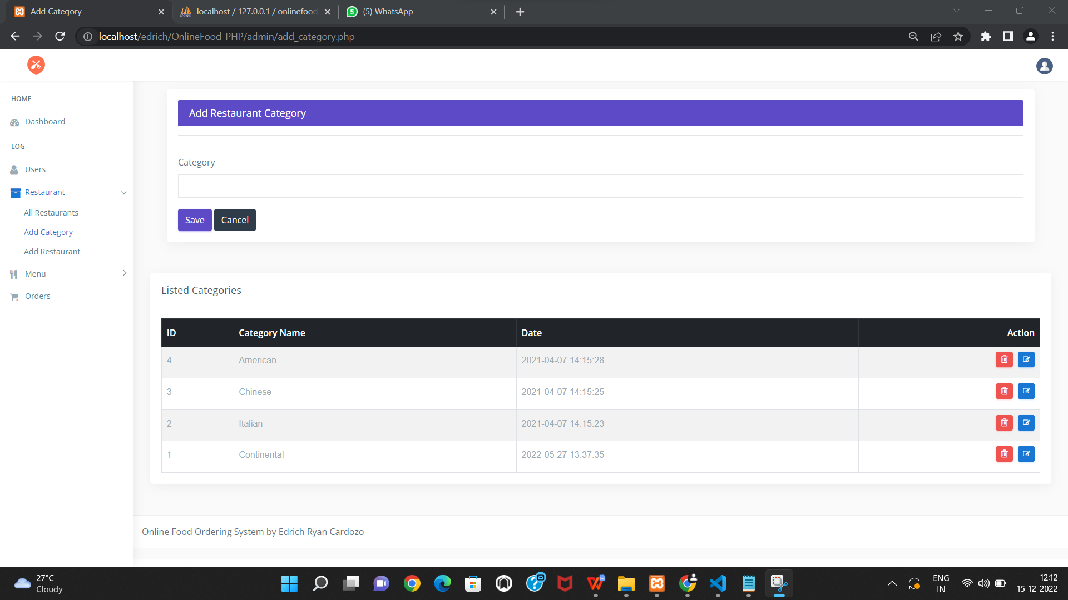

<!DOCTYPE html>

<html lang="en">

<?php

include("../connection/connect.php");

error_reporting(0);

session_start();

if(isset($_POST['submit'] ))

{

if(empty($_POST['c_name']))

{

$error = '<div class="alert alert-danger alert-dismissible fade show">

<button type="button" class="close" data-dismiss="alert" aria-label="Close"><span aria-hidden="true">&times;</span></button>

<strong>field Required!</strong>

</div>';

}

else

{

$check_cat= mysqli_query($db, "SELECT c_name FROM res_category where c_name = '".$_POST['c_name']."' ");

if(mysqli_num_rows($check_cat) > 0)

{

$error = '<div class="alert alert-danger alert-dismissible fade show">

<button type="button" class="close" data-dismiss="alert" aria-label="Close"><span aria-hidden="true">&times;</span></button>

<strong>Category already exist!</strong>

</div>';

}

else{

$mql = "INSERT INTO res_category(c_name) VALUES('".$_POST['c_name']."')";

mysqli_query($db, $mql);

$success = '<div class="alert alert-success alert-dismissible fade show">

<button type="button" class="close" data-dismiss="alert" aria-label="Close"><span aria-hidden="true">&times;</span></button>

New Category Added Successfully.</br></div>';

}

}

}

?>

<head>

<meta charset="utf-8">

<meta http-equiv="X-UA-Compatible" content="IE=edge">

<meta name="viewport" content="width=device-width, initial-scale=1">

<meta name="description" content="">

<meta name="author" content="">

<title>Add Category</title>

<link href="css/lib/bootstrap/bootstrap.min.css" rel="stylesheet">

<link href="css/helper.css" rel="stylesheet">

<link href="css/style.css" rel="stylesheet">

</head>

<body class="fix-header">

<div class="preloader">

<svg class="circular" viewBox="25 25 50 50">

<circle class="path" cx="50" cy="50" r="20" fill="none" stroke-width="2" stroke-miterlimit="10" /> </svg>

</div>

<div id="main-wrapper">

<div class="header">

<nav class="navbar top-navbar navbar-expand-md navbar-light">

<div class="navbar-header">

<a class="navbar-brand" href="dashboard.php">

<span><img src="images/icn.png" alt="homepage" class="dark-logo" /></span>

</a>

</div>

<div class="navbar-collapse">

<ul class="navbar-nav mr-auto mt-md-0">

</ul>

<ul class="navbar-nav my-lg-0">

<li class="nav-item dropdown">

<a class="nav-link dropdown-toggle text-muted " href="#" data-toggle="dropdown" aria-haspopup="true" aria-expanded="false"><img src="images/bookingSystem/user-icn.png" alt="user" class="profile-pic" /></a>

<div class="dropdown-menu dropdown-menu-right animated zoomIn">

<ul class="dropdown-user">

<li><a href="logout.php"><i class="fa fa-power-off"></i> Logout</a></li>

</ul>

</div>

</li>

</ul>

</div>

</nav>

</div>

<div class="left-sidebar">

<div class="scroll-sidebar">

<nav class="sidebar-nav">

<ul id="sidebarnav">

<li class="nav-devider"></li>

<li class="nav-label">Home</li>

<li> <a href="dashboard.php"><i class="fa fa-tachometer"></i><span>Dashboard</span></a></li>

<li class="nav-label">Log</li>

<li> <a href="all_users.php"> <span><i class="fa fa-user f-s-20 "></i></span><span>Users</span></a></li>

<li> <a class="has-arrow " href="#" aria-expanded="false"><i class="fa fa-archive f-s-20 color-warning"></i><span class="hide-menu">Restaurant</span></a>

<ul aria-expanded="false" class="collapse">

<li><a href="all_restaurant.php">All Restaurants</a></li>

<li><a href="add_category.php">Add Category</a></li>

<li><a href="add_restaurant.php">Add Restaurant</a></li>

</ul>

</li>

<li> <a class="has-arrow " href="#" aria-expanded="false"><i class="fa fa-cutlery" aria-hidden="true"></i><span class="hide-menu">Menu</span></a>

<ul aria-expanded="false" class="collapse">

<li><a href="all_menu.php">All Menues</a></li>

<li><a href="add_menu.php">Add Menu</a></li>

</ul>

</li>

<li> <a href="all_orders.php"><i class="fa fa-shopping-cart" aria-hidden="true"></i><span>Orders</span></a></li>

</ul>

</nav>

</div>

</div>

<div class="page-wrapper">

<div class="container-fluid">

<div class="row">

<div class="container-fluid">

<?php

echo $error;

echo $success; ?>

<div class="col-lg-12">

<div class="card card-outline-primary">

<div class="card-header">

<h4 class="m-b-0 text-white">Add Restaurant Category</h4>

</div>

<form action='' method='post' >

<div class="form-body">

<hr>

<div class="row p-t-20">

<div class="col-md-12">

<div class="form-group">

<label class="control-label">Category</label>

<input type="text" name="c_name" class="form-control" >

</div>

</div>

</div>

<div class="form-actions">

<input type="submit" name="submit" class="btn btn-primary" value="Save">

<a href="add_category.php" class="btn btn-inverse">Cancel</a>

</div>

</form>

</div>

</div>

</div>

</div>

<div class="col-12">

<div class="card">

<div class="card-body">

<h4 class="card-title">Listed Categories</h4>

<div class="table-responsive m-t-40">

<table id="myTable" class="table table-bordered table-hover table-striped">

<thead class="thead-dark">

<tr>

<th>ID</th>

<th>Category Name</th>

<th>Date</th>

<th>Action</th>

</tr>

</thead>

<tbody>

<?php

$sql="SELECT * FROM res_category order by c_id desc";

$query=mysqli_query($db,$sql);

if(!mysqli_num_rows($query) > 0 )

{

echo '<td colspan="7"><center>No Categories-Data!</center></td>';

}

else

{

while($rows=mysqli_fetch_array($query))

{

echo ' <tr><td>'.$rows['c_id'].'</td>

<td>'.$rows['c_name'].'</td>

<td>'.$rows['date'].'</td>

<td><a href="delete_category.php?cat_del='.$rows['c_id'].'" class="btn btn-danger btn-flat btn-addon btn-xs m-b-10"><i class="fa fa-trash-o" style="font-size:16px"></i></a>

<a href="update_category.php?cat_upd='.$rows['c_id'].'" " class="btn btn-info btn-flat btn-addon btn-sm m-b-10 m-l-5"><i class="fa fa-edit"></i></a>

</td></tr>';

}

}

?>

</tbody>

</table>

Add restaurant:

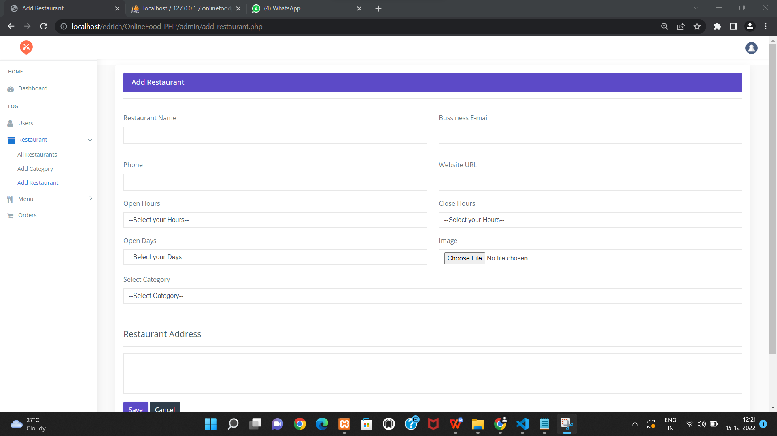

<div class="page-wrapper">

<div class="container-fluid">

<?php echo $error;

echo $success; ?>

<div class="col-lg-12">

<div class="card card-outline-primary">

<div class="card-header">

<h4 class="m-b-0 text-white">Add Restaurant</h4>

</div>

<div class="card-body">

<form action='' method='post' enctype="multipart/form-data">

<div class="form-body">

<hr>

<div class="row p-t-20">

<div class="col-md-6">

<div class="form-group">

<label class="control-label">Restaurant Name</label>

<input type="text" name="res_name" class="form-control">

</div>

</div>

<div class="col-md-6">

<div class="form-group has-danger">

<label class="control-label">Bussiness E-mail</label>

<input type="text" name="email" class="form-control form-control-danger" >

</div>

</div>

</div>

<div class="row p-t-20">

<div class="col-md-6">

<div class="form-group">

<label class="control-label">Phone </label>

<input type="text" name="phone" class="form-control" >

</div>

</div>

<div class="col-md-6">

<div class="form-group has-danger">

<label class="control-label">Website URL</label>

<input type="text" name="url" class="form-control form-control-danger" >

</div>

</div>

</div>

<div class="row">

<div class="col-md-6">

<div class="form-group">

<label class="control-label">Open Hours</label>

<select name="o_hr" class="form-control custom-select" data-placeholder="Choose a Category" >

<option>--Select your Hours--</option>

<option value="6am">6am</option>

<option value="7am">7am</option>

<option value="8am">8am</option>

<option value="9am">9am</option>

<option value="10am">10am</option>

<option value="11am">11am</option>

<option value="12pm">12pm</option>

</select>

</div>

</div>

<div class="col-md-6">

<div class="form-group">

<label class="control-label">Close Hours</label>

<select name="c_hr" class="form-control custom-select" data-placeholder="Choose a Category" >

<option>--Select your Hours--</option>

<option value="3pm">3pm</option>

<option value="4pm">4pm</option>

<option value="5pm">5pm</option>

<option value="6pm">6pm</option>

<option value="7pm">7pm</option>

<option value="8pm">8pm</option>

<option value="9pm">9pm</option>

<option value="10pm">10pm</option>

<option value="11pm">11pm</option>

<option value="12am">12am</option>

<option value="1am">1am</option>

<option value="2am">2am</option>

<option value="3am">3am</option>

</select>

</div>

</div>

<div class="col-md-6">

<div class="form-group">

<label class="control-label">Open Days</label>

<select name="o_days" class="form-control custom-select" data-placeholder="Choose a Category" tabindex="1">

<option>--Select your Days--</option>

<option value="Mon-Tue">Mon-Tue</option>

<option value="Mon-Wed">Mon-Wed</option>

<option value="Mon-Thu">Mon-Thu</option>

<option value="Mon-Fri">Mon-Fri</option>

<option value="Mon-Sat">Mon-Sat</option>

<option value="24hr-x7">24hr-x7</option>

</select>

</div>

</div>

<div class="col-md-6">

<div class="form-group has-danger">

<label class="control-label">Image</label>

<input type="file" name="file" id="lastName" class="form-control form-control-danger" placeholder="12n">

</div>

</div>

<div class="col-md-12">

<div class="form-group">

<label class="control-label">Select Category</label>

<select name="c_name" class="form-control custom-select" data-placeholder="Choose a Category" tabindex="1">

<option>--Select Category--</option>

<?php $ssql ="select * from res_category";

$res=mysqli_query($db, $ssql);

while($row=mysqli_fetch_array($res))

{

echo' <option value="'.$row['c_id'].'">'.$row['c_name'].'</option>';;

}

?>

</select>

</div>

</div>

</div>

<h3 class="box-title m-t-40">Restaurant Address</h3>

<hr>

<div class="row">

<div class="col-md-12 ">

<div class="form-group">

<textarea name="address" type="text" style="height:100px;" class="form-control"></textarea>

</div>

</div>

</div>

</div>

</div>

<div class="form-actions">

<input type="submit" name="submit" class="btn btn-primary" value="Save">

<a href="add_restaurant.php" class="btn btn-inverse">Cancel</a>

</div>

</form>

</div>

</div>

</div>

<footer class="footer">Online Food Ordering System by Edrich Ryan Cardozo </footer>

</div>

</div>

All menus :

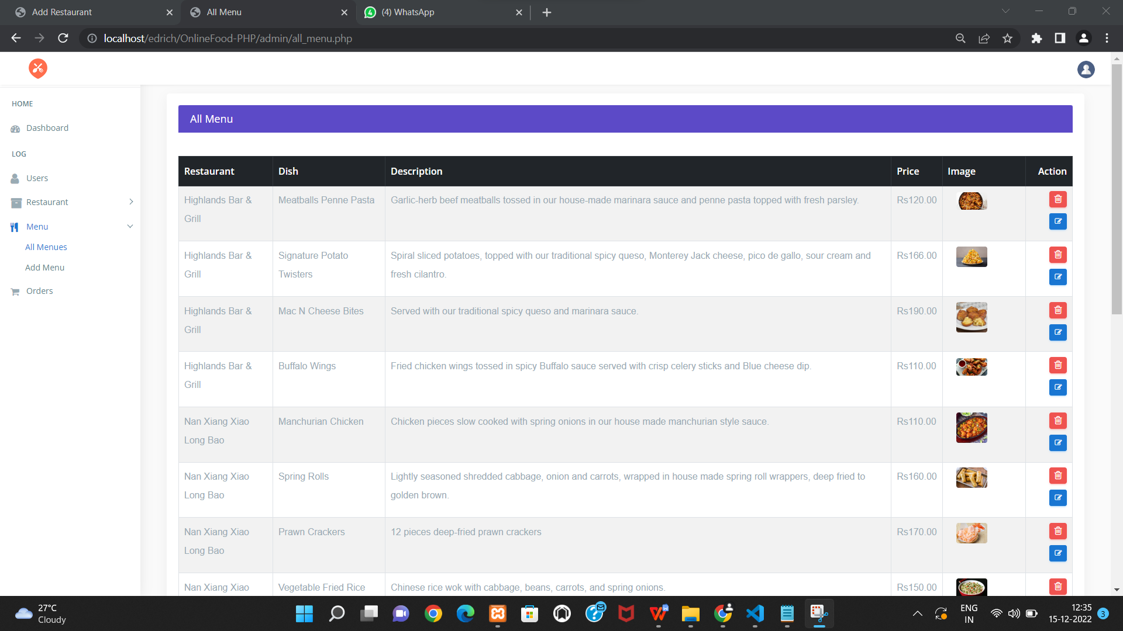

<!DOCTYPE html>

<html lang="en">

<?php

include("../connection/connect.php");

error_reporting(0);

session_start();

?>

<div class="card card-outline-primary">

<div class="card-header">

<h4 class="m-b-0 text-white">All Menu</h4>

</div>

<div class="table-responsive m-t-40">

<table id="example23" class="display nowrap table table-hover table-striped table-bordered" cellspacing="0" width="100%">

<thead class="thead-dark">

<tr>

<th>Restaurant</th>

<th>Dish</th>

<th>Description</th>

<th>Price</th>

<th>Image</th>

<th>Action</th>

</tr>

</thead>

<tbody>

<?php

$sql="SELECT * FROM dishes order by d_id desc";

$query=mysqli_query($db,$sql);

if(!mysqli_num_rows($query) > 0 )

{

echo '<td colspan="11"><center>No Menu</center></td>';

}

else

{

while($rows=mysqli_fetch_array($query))

{

$mql="select * from restaurant where rs_id='".$rows['rs_id']."'";

$newquery=mysqli_query($db,$mql);

$fetch=mysqli_fetch_array($newquery);

echo '<tr><td>'.$fetch['title'].'</td>

<td>'.$rows['title'].'</td>

<td>'.$rows['slogan'].'</td>

<td>Rs'.$rows['price'].'</td>

<td><div class="col-md-3 col-lg-8 m-b-10">

<center><img src="Res_img/dishes/'.$rows['img'].'" class="img-responsive radius" style="max-height:100px;max-width:150px;" /></center>

</div></td>

<td><a href="delete_menu.php?menu_del='.$rows['d_id'].'" class="btn btn-danger btn-flat btn-addon btn-xs m-b-10"><i class="fa fa-trash-o" style="font-size:16px"></i></a>

<a href="update_menu.php?menu_upd='.$rows['d_id'].'" class="btn btn-info btn-flat btn-addon btn-sm m-b-10 m-l-5"><i class="fa fa-edit"></i></a>

</td></tr>';

}

}

?>

</tbody>

</table>

</div>

</div>

</div>

</div>

</div>

</div>

</div>

</div>

</div>

<footer class="footer">Online Food Ordering System by Edrich Ryan Cardozo</footer>

Add menu:

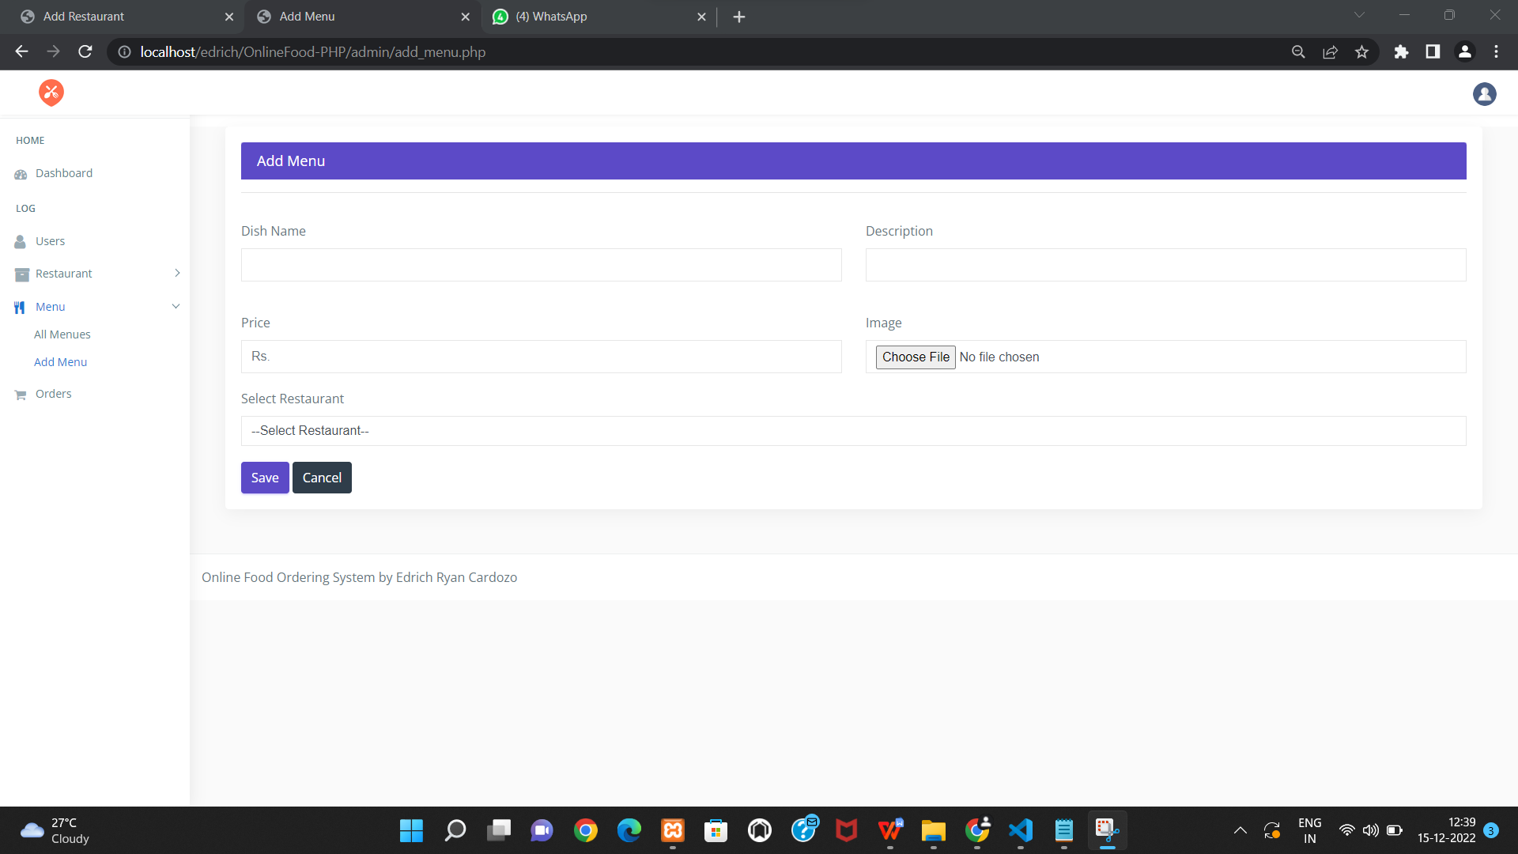

<!DOCTYPE html>

<html lang="en">

<?php

include("../connection/connect.php");

error_reporting(0);

session_start();

if(isset($_POST['submit']))

{

if(empty($_POST['d_name'])||empty($_POST['about'])||$_POST['price']==''||$_POST['res_name']=='')

{

$error = '<div class="alert alert-danger alert-dismissible fade show">

<button type="button" class="close" data-dismiss="alert" aria-label="Close"><span aria-hidden="true">&times;</span></button>

<strong>All fields Must be Fillup!</strong>

</div>';

}

else

{

$fname = $_FILES['file']['name'];

$temp = $_FILES['file']['tmp_name'];

$fsize = $_FILES['file']['size'];

$extension = explode('.',$fname);

$extension = strtolower(end($extension));

$fnew = uniqid().'.'.$extension;

$store = "Res_img/dishes/".basename($fnew);

if($extension == 'jpg'||$extension == 'png'||$extension == 'gif' )

{

if($fsize>=1000000)

{

$error = '<div class="alert alert-danger alert-dismissible fade show">

<button type="button" class="close" data-dismiss="alert" aria-label="Close"><span aria-hidden="true">&times;</span></button>

<strong>Max Image Size is 1024kb!</strong> Try different Image.

</div>';

}

else

{

$sql = "INSERT INTO dishes(rs_id,title,slogan,price,img) VALUE('".$_POST['res_name']."','".$_POST['d_name']."','".$_POST['about']."','".$_POST['price']."','".$fnew."')"; // store the submited data ino the database :images

mysqli_query($db, $sql);

move_uploaded_file($temp, $store);

$success = '<div class="alert alert-success alert-dismissible fade show">

<button type="button" class="close" data-dismiss="alert" aria-label="Close"><span aria-hidden="true">&times;</span></button>

New Dish Added Successfully.

</div>';

}

}

elseif($extension == '')

{

$error = '<div class="alert alert-danger alert-dismissible fade show">

<button type="button" class="close" data-dismiss="alert" aria-label="Close"><span aria-hidden="true">&times;</span></button>

<strong>select image</strong>

</div>';

}

else{

$error = '<div class="alert alert-danger alert-dismissible fade show">

<button type="button" class="close" data-dismiss="alert" aria-label="Close"><span aria-hidden="true">&times;</span></button>

<strong>invalid extension!</strong>png, jpg, Gif are accepted.

</div>';

}

}

}

?>

<div class="page-wrapper">

<div class="container-fluid">

<!-- Start Page Content -->

<?php echo $error;

echo $success; ?>

<div class="col-lg-12">

<div class="card card-outline-primary">

<div class="card-header">

<h4 class="m-b-0 text-white">Add Menu</h4>

</div>

<div class="card-body">

<form action='' method='post' enctype="multipart/form-data">

<div class="form-body">

<hr>

<div class="row p-t-20">

<div class="col-md-6">

<div class="form-group">

<label class="control-label">Dish Name</label>

<input type="text" name="d_name" class="form-control" >

</div>

</div>

<div class="col-md-6">

<div class="form-group has-danger">

<label class="control-label">Description</label>

<input type="text" name="about" class="form-control form-control-danger" >

</div>

</div>

</div>

<div class="row p-t-20">

<div class="col-md-6">

<div class="form-group">

<label class="control-label">Price </label>

<input type="text" name="price" class="form-control" placeholder="Rs.">

</div>

</div>

<div class="col-md-6">

<div class="form-group has-danger">

<label class="control-label">Image</label>

<input type="file" name="file" id="lastName" class="form-control form-control-danger" placeholder="12n">

</div>

</div>

</div>

<div class="row">

<div class="col-md-12">

<div class="form-group">

<label class="control-label">Select Restaurant</label>

<select name="res_name" class="form-control custom-select" data-placeholder="Choose a Category" tabindex="1">

<option>--Select Restaurant--</option>

<?php $ssql ="select * from restaurant";

$res=mysqli_query($db, $ssql);

while($row=mysqli_fetch_array($res))

{

echo' <option value="'.$row['rs_id'].'">'.$row['title'].'</option>';;

}

?>

</select>

</div>

</div>

</div>

</div>

</div>

<div class="form-actions">

<input type="submit" name="submit" class="btn btn-primary" value="Save">

<a href="add_menu.php" class="btn btn-inverse">Cancel</a>

</div>

</form>

</div>

</div>

</div>

<footer class="footer">Online Food Ordering System by Edrich Ryan Cardozo </footer>

Orders :

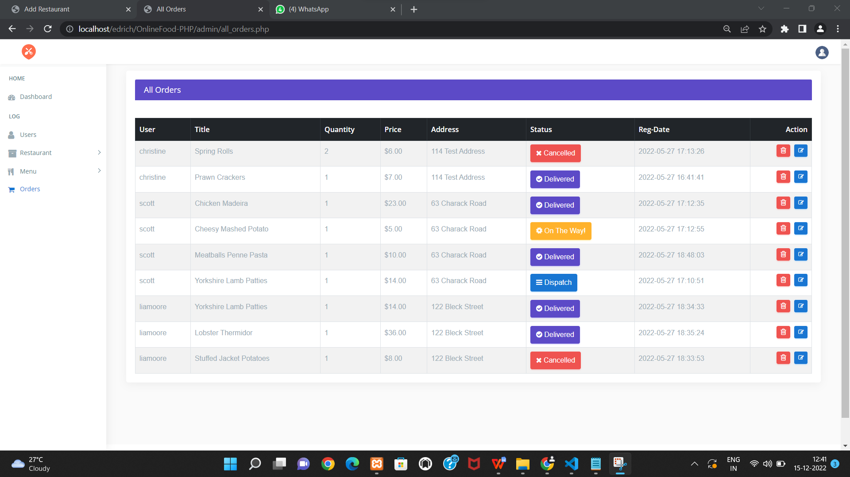

<!DOCTYPE html>

<html lang="en">

<?php

include("../connection/connect.php");

error_reporting(0);

session_start();

?>

<div class="page-wrapper">

<div class="container-fluid">

<div class="row">

<div class="col-12">

<div class="col-lg-12">

<div class="card card-outline-primary">

<div class="card-header">

<h4 class="m-b-0 text-white">All Orders</h4>

</div>

<div class="table-responsive m-t-40">

<table id="myTable" class="table table-bordered table-striped">

<thead class="thead-dark">

<tr>

<th>User</th>

<th>Title</th>

<th>Quantity</th>

<th>Price</th>

<th>Address</th>

<th>Status</th>

<th>Reg-Date</th>

<th>Action</th> </tr> </thead><tbody>

<?php$sql="SELECT users.*, users_orders.* FROM users INNER JOIN users_orders ON users.u_id=users_orders.u_id "; $query=mysqli_query($db,$sql);if(!mysqli_num_rows($query) > 0 ){

echo '<td colspan="8"><center>No Orders</center></td>';

}else{ while($rows=mysqli_fetch_array($query)){?><?php

echo ' <tr>

<td>'.$rows['username'].'</td>

<td>'.$rows['title'].'</td>

<td>'.$rows['quantity'].'</td>

<td>$'.$rows['price'].'</td>

<td>'.$rows['address'].'</td>';

?>

<?php

$status=$rows['status'];

if($status=="" or $status=="NULL")

{

?>

<td> <button type="button" class="btn btn-info"><span class="fa fa-bars" aria-hidden="true" ></span> Dispatch</button></td>

<?php

}

if($status=="in process")

{ ?>

<td> <button type="button" class="btn btn-warning"><span class="fa fa-cog fa-spin" aria-hidden="true" ></span> On The Way!</button></td>

<?php

}

if($status=="closed")

{

?>

<td> <button type="button" class="btn btn-primary" ><span class="fa fa-check-circle" aria-hidden="true"></span> Delivered</button></td>

<?php

}

?>

<?php

if($status=="rejected"{?><td> <button type="button" class="btn btn-danger"> <i class="fa fa-close"></i> Cancelled</button></td>

<?php

} ?>

<?php

echo ' <td>'.$rows['date'].'</td>'; ?> <td> <a href="delete_orders.php?order_del=<?php echo $rows['o_id'];?>" onclick="return confirm('Are you sure?');" class="btn btn-danger btn-flat btn-addon btn-xs m-b-10"><i class="fa fa-trash-o" style="font-size:16px"></i></a> <?php

echo '<a href="view_order.php?user_upd='.$rows['o_id'].'" " class="btn btn-info btn-flat btn-addon btn-sm m-b-10 m-l-5"><i class="fa fa-edit"></i></a> </td> </tr>';}}?>

</tbody>

</table>

</div> </div> </div></div> </div></div></div.</div></div>

<footer class="footer">Online Food Ordering System by Edrich Ryan Cardozo </footer>

Delete codes :

1. Category:

<?php

include("../connection/connect.php");

error_reporting(0);

session_start();

mysqli_query($db,"DELETE FROM res_category WHERE c_id = '".$_GET['cat_del']."'");

header("location:add_category.php");

?>

1. Menu

<?php

include("../connection/connect.php");

error_reporting(0);

session_start();

mysqli_query($db,"DELETE FROM dishes WHERE d_id = '".$_GET['menu_del']."'");

header("location:all_menu.php");

?>

1. orders :

<?php

include("../connection/connect.php");

error_reporting(0);

session_start();

mysqli_query($db,"DELETE FROM users_orders WHERE o_id = '".$_GET['order_del']."'");

header("location:all_orders.php");

?>

1. restraunt:

<?php

include("../connection/connect.php");

error_reporting(0);

session_start();

mysqli_query($db,"DELETE FROM restaurant WHERE rs_id = '".$_GET['res_del']."'");

header("location:all_restaurant.php");

?>

1. user:

<?php

include("../connection/connect.php");

error_reporting(0);

session_start();

mysqli_query($db,"DELETE FROM users WHERE u_id = '".$_GET['user_del']."'");

header("location:all_users.php");

?>

Update order status :

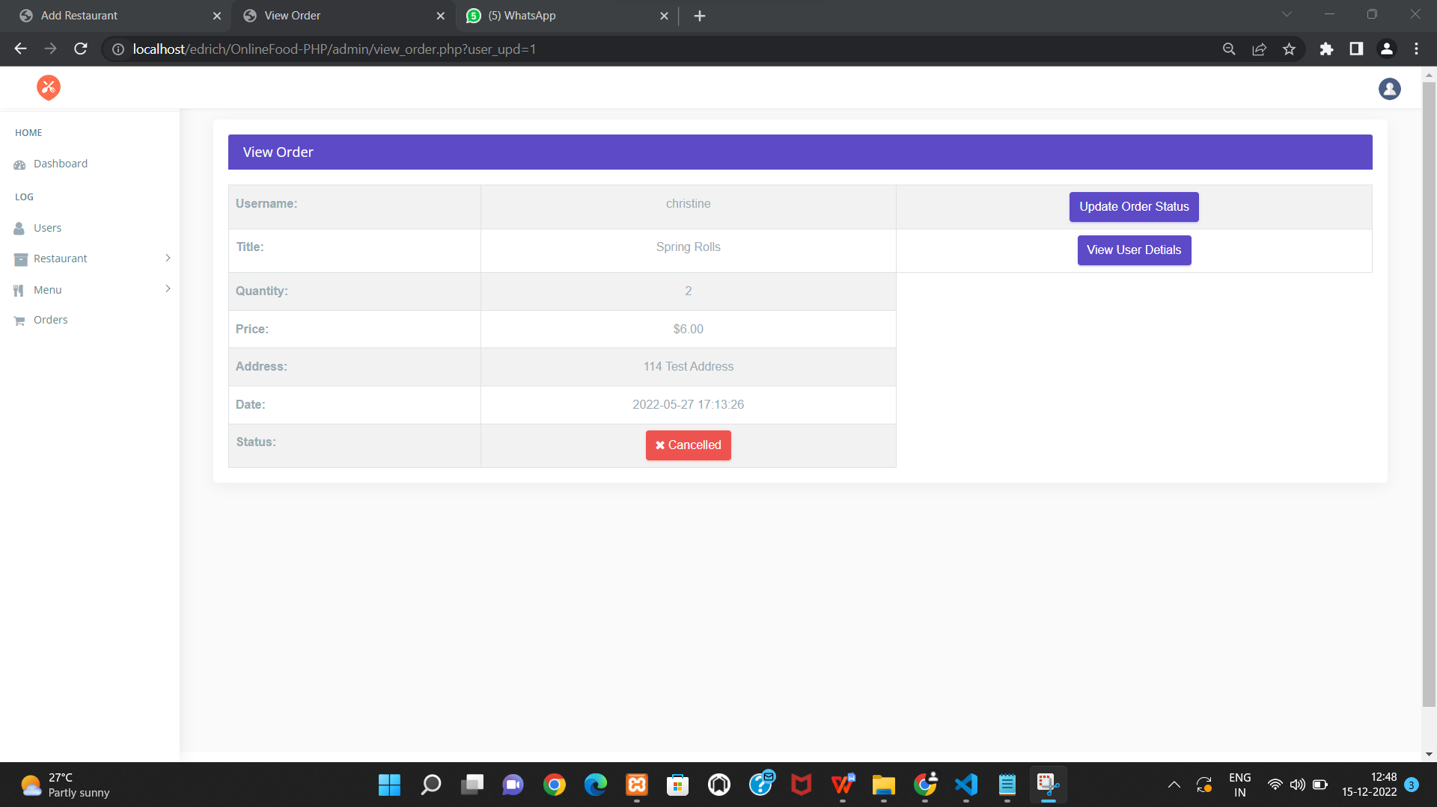

<?php

include("../connection/connect.php");

error_reporting(0);

session_start();

if(strlen($_SESSION['user_id'])==0)

{

header('location:../login.php');

}

else

{

if(isset($_POST['update']))

{

$form_id=$_GET['form_id'];

$status=$_POST['status'];

$remark=$_POST['remark'];

$query=mysqli_query($db,"insert into remark(frm_id,status,remark) values('$form_id','$status','$remark')");

$sql=mysqli_query($db,"update users_orders set status='$status' where o_id='$form_id'");

echo "<script>alert('Form Details Updated Successfully');</script>";

}

?>

<script language="javascript" type="text/javascript">

function f2()

{

window.close();

}ser

function f3()

{

window.print();

}

</script>

<head>

<meta charset="utf-8">

<meta http-equiv="X-UA-Compatible" content="IE=edge">

<meta name="viewport" content="width=device-width, initial-scale=1">

<meta name="description" content="">

<meta name="author" content="">

<link rel="icon" type="image/png" sizes="16x16" href="images/favicon.png">

<title>Order Update</title>

<link href="css/lib/bootstrap/bootstrap.min.css" rel="stylesheet">

<link href="css/helper.css" rel="stylesheet">

<link href="css/style.css" rel="stylesheet">

<script src="https://ajax.googleapis.com/ajax/libs/jquery/3.3.1/jquery.min.js"></script>

<style type="text/css" rel="stylesheet">

.indent-small {

margin-left: 5px;

}

.form-group.internal {

margin-bottom: 0;

}

.dialog-panel {

margin: 10px;

}

.datepicker-dropdown {

z-index: 200 !important;

}

.panel-body {

background: #e5e5e5;

background: -moz-radial-gradient(center, ellipse cover, #e5e5e5 0%, #ffffff 100%);

background: -webkit-gradient(radial, center center, 0px, center center, 100%, color-stop(0%, #e5e5e5), color-stop(100%, #ffffff));

background: -webkit-radial-gradient(center, ellipse cover, #e5e5e5 0%, #ffffff 100%);

background: -o-radial-gradient(center, ellipse cover, #e5e5e5 0%, #ffffff 100%);

background: -ms-radial-gradient(center, ellipse cover, #e5e5e5 0%, #ffffff 100%);

background: radial-gradient(ellipse at center, #e5e5e5 0%, #ffffff 100%);

filter: progid:DXImageTransform.Microsoft.gradient(startColorstr='#e5e5e5', endColorstr='#ffffff', GradientType=1);

font: 600 15px "Open Sans", Arial, sans-serif;

}

label.control-label {

font-weight: 600;

color: #777;

}

table {

width: 650px;

border-collapse: collapse;

margin: auto;

margin-top:50px;}

tr:nth-of-type(odd) {

background: #eee; }

th {

background: #004684;

color: white;

font-weight: bold; }

td, th {

padding: 10px;

border: 1px solid #ccc;

text-align: left;

font-size: 14px;}

</style>

</head>

<body>

<div style="margin-left:50px;">

<form name="updateticket" id="updatecomplaint" method="post">

<table border="0" cellspacing="0" cellpadding="0">

<tr >

<td><b>Form Number</b></td>

<td><?php echo htmlentities($_GET['form_id']); ?></td>

</tr>

<tr>

<td >&nbsp;</td>

<td >&nbsp;</td>

</tr>

<tr >

<td><b>Status</b></td>

<td><select name="status" required="required" >

<option value="">Select Status</option>

<option value="in process">On the way</option>

<option value="closed">Delivered</option>

<option value="rejected">Cancelled</option>

</select></td>

</tr>

<tr >

<td><b>Message</b></td>

<td><textarea name="remark" cols="50" rows="10" required="required"></textarea></td>

</tr>

<tr>

<td><b>Action</b></td>

<td><input type="submit" name="update" class="btn btn-primary" value="Submit">

<input name="Submit2" type="submit" class="btn btn-danger" value="Close this window " onClick="return f2();" style="cursor: pointer;" /></td>

</tr>

</table>

</form>

</div>

</body>

</html>

<?php } ?>

Update category :

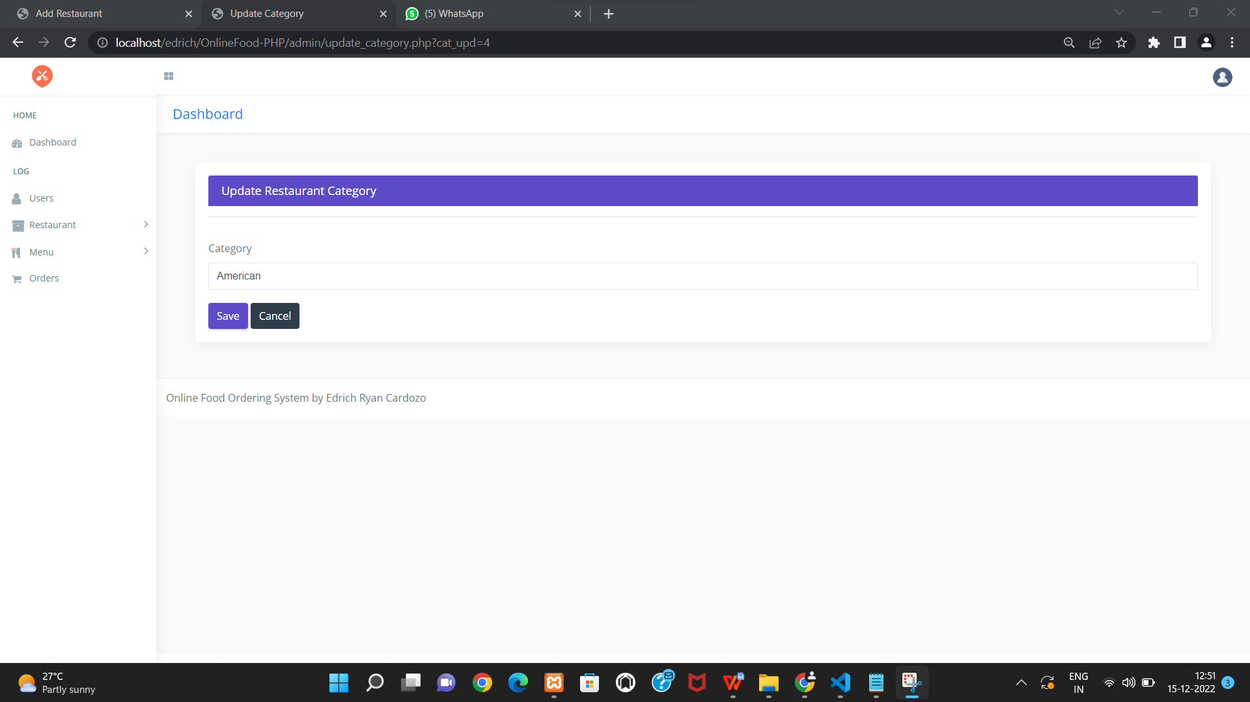

<!DOCTYPE html>

<html lang="en">

<?php

include("../connection/connect.php");

error_reporting(0);

session_start();

if(isset($_POST['submit'] )){

if(empty($_POST['c_name']))

{$error = '<div class="alert alert-danger alert-dismissible fade show">\

<button type="button" class="close" data-dismiss="alert" aria-label="Close"><span aria-hidden="true">&times;</span></button> <strong>field Required!</strong>

</div>';}

else{

$mql = "update res_category set c_name ='$_POST[c_name]' where c_id='$_GET[cat_upd]'";

mysqli_query($db, $mql);

$success = '<div class="alert alert-success alert-dismissible fade show"> <button type="button" class="close" data-dismiss="alert" aria-label="Close"><span aria-hidden="true">&times;</span></button>

strong>Updated!</strong> Successfully.</br></div>';}}

?><div class="container-fluid"> <div class="row">

<div class="container-fluid">

<?php echo $error; echo $success; ?>

<div class="col-lg-12">

<div class="card card-outline-primary">

<div class="card-header">

<h4 class="m-b-0 text-white">Update Restaurant Category</h4>

</div>

<div class="card-body">

<form action='' method='post' >

<div class="form-body">

<?php $ssql ="select * from res_category where c_id='$_GET[cat_upd]'"; $res=mysqli_query($db, $ssql); $row=mysqli_fetch_array($res);?>

<hr>

<div class="row p-t-20">

<div class="col-md-12">

<div class="form-group">

<label class="control-label">Category</label>

<input type="text" name="c_name" value="<?php echo $row['c_name']; ?>" class="form-control" placeholder="Category Name">

</div>

</div>

</div>

<div class="form-actions">

<input type="submit" name="submit" class="btn btn-primary" value="Save">

<a href="add_category.php" class="btn btn-inverse">Cancel</a>

</div>

</form>

</div>

</div>

</div>

</div>

</div>

</div>

<footer class="footer">Online Food Ordering System by Edrich Ryan Cardozo </footer>

</div>